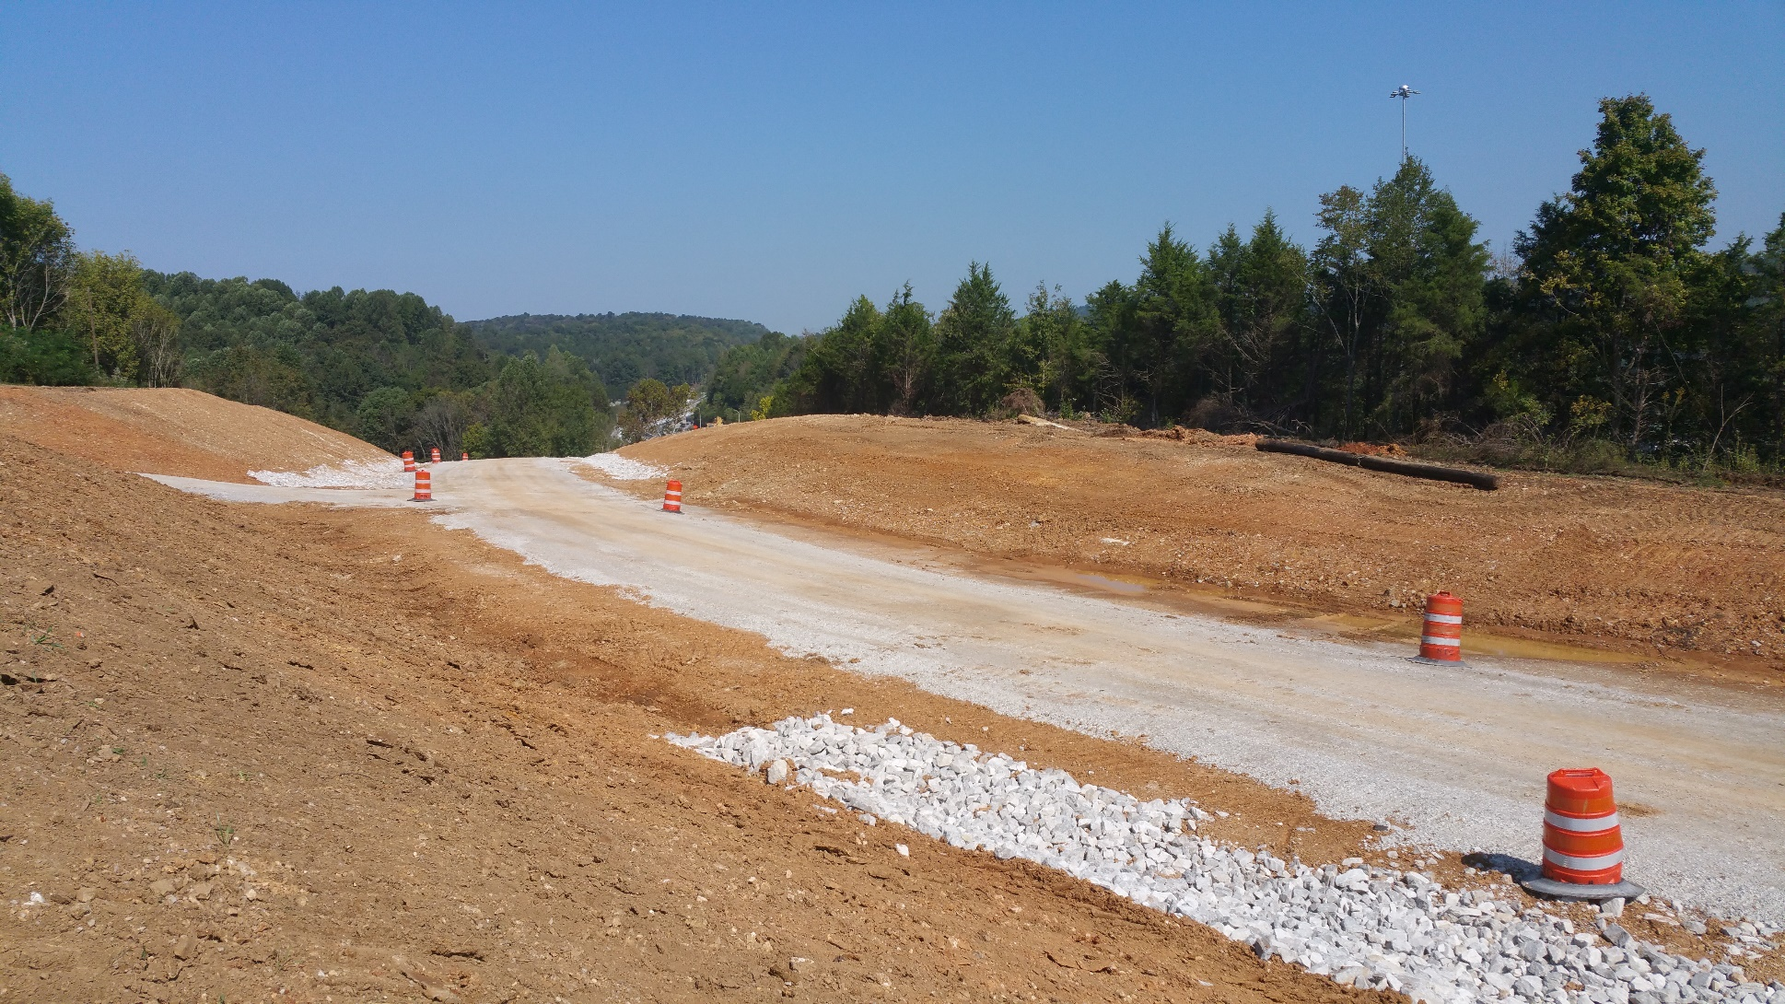

Continuous

Highway

Analysis Framework

**USER GUIDE**

**December 2018**

Version 2.0

**Prepared For:**

Division of Planning, Districts, MPOs, and ADDs

**SPAC Branch**

Kentucky Transportation Cabinet



|  |  |  |  |  |
| --- | --- | --- | --- | --- |
| **Document Revision History** | | | | |
| **Version** | **Date** | **Changes** | **Revision Mark** | **Updated By** |
| 1.0 | 11/2017 | Original document |  | Kevin Fugette |
| 2.0 | 11/2018 | Revised for Users of CHAF |  | Maridely M. Loyselle |
|  |  |  |  |  |
|  |  |  |  |  |

**Table of Contents**

DEFINITIONS 5

INTRODUCTION 8

Authentication 8

Authorization 8

CHAF ACCESS PROCEDURES 9

KYTC Users Initial Access Request 9

Non-KYTC Users Initial Access Request 10

CHAF’S MENUS 13

Menu Bar 13

Update of User Profile 15

Dashboard 15

Dashboard Widgets 16

Project Search 16

Request Project 17

Project and User Requests 17

Links Widgets 18

SHIFT Cycle Widgets 18

Project Grid 18

PROJECT REQUEST 21

Request Project Procedures 21

EDITING PROJECTS 24

Edit Project Procedure 24

Project Status 26

Project Location 27

Bridge Details 28

PURPOSE AND NEED 30

Cost Estimate of Projects 31

Project Characteristics 33

PROJECT MAPS 36

Edit Mile Points 38

Location Type 39

Map Tools 39

Cardinal Vs Non-Cardinal 40

Project Across a County Line 42

Route Order 42

ATTACHMENTS 44

PROJECT REPORT 45

Report Summary 46

SHIFT CYCLE 48

Sponsorship 48

Sponsor a Project 48

List of Sponsor Project 50

Scoring Data Validation 50

Local Input 51

INDEX 53

# DEFINITIONS

**2 Lane to 4 Lane Divided-Rural** – The upgrade of an existing two lane highway to a 4 lane divided facility to increase traffic flow.

**2 Lane to 4 Lane Divided-Urban** – The upgrade of an existing two lane highway to a 4 lane divided facility to increase traffic flow.

**Access Consolidation** –Replace TWTL with a divided median cross section with no additional capacity. Add non-traversable median.

**Add Lane to Full Control Facility** – The addition of a full lane of travel to an Interstate or existing Full Access Controlled facility.

**Arterial to Full Control** – Upgrading a road serving major traffic movements (high-speed, high volume) for travel between major points to a divided arterial highway for the unimpeded flow of large traffic volumes.

**Arterial to Partial Control** –Upgrading a road serving major traffic movements (high-speed, high volume) for travel between major points to alleviate congestion and reduce impediments to traffic flow. Include indirect left turn or similar movements.

**Auxiliary Lanes or Operational Improvements** – Add continuous auxiliary lane for weaving between entrance ramp and exit ramp or other interchange improvements.

**Bike and Pedestrian Improvements** – Add sidewalk to one side of roadway, add separated mixed use trail to one side of roadway, add bike lane to one or both sides of roadway, add pedestrian signal at signalized intersection.

**Cardinal Direction** – The direction in which the mile point are in ascending order. This is the portion of the route that has data attached to it.

**Construct Road in new location** – Bypass, New Route, New Interchange, Route Relocation. Does not include construction of new local roadways.

**Credentials** – CHAF ID and usernames.

**Existing route** – The route(s), intersection(s), interchange(s), and/or ramp(s) on which the work is being done or is an important part of the project.

**Full Control to Interstate** – Improving an existing freeway to interstate design standards primarily by increasing shoulder width and/or bridge clearances.

**Grade Separated to Interchange** – The addition of ramps to an existing grade separated interchange.

**Grade Separation of Highway/Railroad Crossing** – Construct Grade Separation to Separate two Modes.

**Identified Project** – A project that has been added to CHAF and is an active project.

**Impacted Route** – The route(s) and/or ramp(s) which are affected by the project or will be affected by the construction of a new route. This primary applies to the traffic from an existing route that will use the new route.

**Improve Intersection** –Install left turn lane, Install right turn lane, offset Left turns, new signal, etc.

**Improve Railroad Crossing** – Install flashing lights and sound signals and/or automatic gates.

**Inactive Project** – An inactive project can be several things: a project that is no longer being worked on, a completed project, a project that got funded by a different source, and a project that needs to be deleted from CHAF.

**Innovative Interchange** – Improve an interchange by converting the existing interchange to an innovative interchange such as diverging diamond or SPUI (single point urban interchange).

**Innovative Intersection** –Improve an intersection by employing an innovative intersection design such as a roundabout, J turn, restricted crossing U-turn, median U-turn, etc.

**Install Cameras and DMS** – Intelligent Transportation System projects.

**Install Two-way Left Turn Lane** – Widening existing pavement through addition of Two Left Turn Lane. Typically used in areas where there appears to an issue with turning related crashes such as rear-end and head-on on two lane roads.

*Note****:****Does not include Road Diets where number of through lanes will be reduced.*

**Interchange Safety Improvements** – Improve the safety of an interchange by extending acceleration/deceleration ramps, converting a cloverleaf interchange to a stop controlled interchange, etc.

**Local Roadway Improvements** – The minor widening, primarily increasing shoulder width etc., on local roads or the construction of a new local route to improve local transportation movements. Improvements to be made on County Roads or City Streets.

**Maintenance Improvement** – Drainage improvements, rock fall, landslides, rest area rehab, resurfacing, rock fall mitigation, signs, weigh station rehab or signals.

**Major Interchange Reconstruction** – Reconstruct interchange to reduce conflict points or improve ramp geometry by adding loops or flyovers or replacing loops with directional ramps.

**Major Widening-Rural Multilane** – Widening of existing multilane rural highways to include additional through lanes.  Does not include fully controlled-access facilities.

**Major Widening-Urban Streets** – Widening of urban streets to include additional through lanes.  Does not include fully controlled-access facilities.

**Modernize & Widen Roadway-Rural** – Realignment or reconstruction to bring geometric (Vertical, horizontal) deficiencies up to modern standards and to provide additional through capacity, including passing lanes or 2+1 configuration.

**Modernize Roadway-Rural** – Realignment or reconstruction to bring geometric (Vertical, horizontal) deficiencies up to modern standards, etc. To include minor Widening of lanes and shoulders, Reconstruction, Safety Hazard eliminations, Spot Improvements, Turn Lanes.

**Modernize Roadway-Urban** – Reconstruction of urban roadway without additional through lanes; may include curb and gutter, bike lanes, sidewalks, etc.

**Need** – Why is the project being done, what problem needs to be solved?

**Non-Cardinal Direction** – The direction in which the miles point going in a descending order. This portion of the route does not have data attached to it.

**Order** – The order applies to the route order in the maps.

**Other improvement Types** – Any improvement types not included previously.

**Proposed Project Area** – Approximate area where the project will be, this is good for projects in the planning and early design stages.

**Proposed Route** – The new or realigned route(s), intersection(s), interchange(s), and/or ramp(s) that the project is proposing to solve the need of the project.

**Purpose** – What problem is the project going to solve?

**Realign Intersection** – Improving the geometric configuration of multiple adjacent intersections (offset approaches) to enhance traffic flow. Reduce Skew for Intersections, Convert Two 3-Leg Intersections to a 4-Leg Intersection.

**Road Diet** – Reconfigure roadway to convert through lanes to a two-way left turn lane.  May include bike lanes.  Typically is when a 4 lane undivided urban road is converted to a 3 lane section with bike lanes.

**Transportation Studies** – Scoping studies, feasibility studies, PE & Environmental, Phase 1 Design, Small Urban Area or Strategic Corridor**.**

**Upgrade to Grade Separation** – Improving an intersection by separating traffic through physical means such as an overpass to allow different flows of traffic. Reduces conflict points and increases capacity of the system.

# INTRODUCTION

Continuous Highways Analysis Framework (CHAF), is an application enabling users to collect, track and analyze identified transportation needs. CHAF also provides a means to sponsor, score and rank projects as part of the Strategic Highway Investment Formula for Tomorrow (SHIFT).

This is the first step in an initiative to link all highway project related systems together. The goals of the initiative are to eliminate duplicate data entry, and provide seamless integration of the highway project information ensuing in more efficient and accurate project reporting.

## Authentication

All Kentucky Transportation Cabinet (KYTC) users are authenticated by their Active Directory credentials of their username and password that they use to sign onto their computers. If configured properly, your browser will automatically sign you into CHAF.

**KYTC Users Link:** [**https://apps.intranet.kytc.ky.gov/CHAF/Home/Dashboard**](https://apps.intranet.kytc.ky.gov/CHAF/Home/Dashboard)

Non-KYTC users, Metropolitan Planning Organizations (MPOs) and Area Development Districts (ADDs), will need to use credentials obtained through Kentucky Business One Stop (KYBOS). All Non-KYTC users must create an account in KYBOS before they request access authorization to CHAF.

**Non-KYTC Users Link:** [**https://apps.transportation.ky.gov/CHAF/Home/Dashboard**](https://apps.transportation.ky.gov/CHAF/Home/Dashboard)**.**

## Authorization

All users must be authorized to use CHAF by the CHAF Program Manager at KYTC Central Office. As part of the authorization process, the user’s organization name and type will be set along with any special authority they may need.

# CHAF ACCESS PROCEDURES

## KYTC Users Initial Access Request

The process to request access for KYTC users is as follows:

1. Copy/paste or enter the link below in your browser.

**KYTC Users Link:** [**https://apps.intranet.kytc.ky.gov/CHAF/Home/Dashboard**](https://apps.intranet.kytc.ky.gov/CHAF/Home/Dashboard)

1. The User Profile window will open (See Figure 1). Enter your information in the User Profile boxes, making sure all fields are complete. Press the blue save button.
2. After the User Profile is completed and saved, send an email to the KYTC Central Office CHAF Program Manager stating your User Profile has been submitted and is ready for review.
3. A notification of approval or denial will be sent via email by the CHAF Program Manager.
4. When CHAF authorization has been approved, access to CHAF can be obtained by clicking the link in the authorization email or using the link in step 1 above.

**Figure 1 - User Profile**

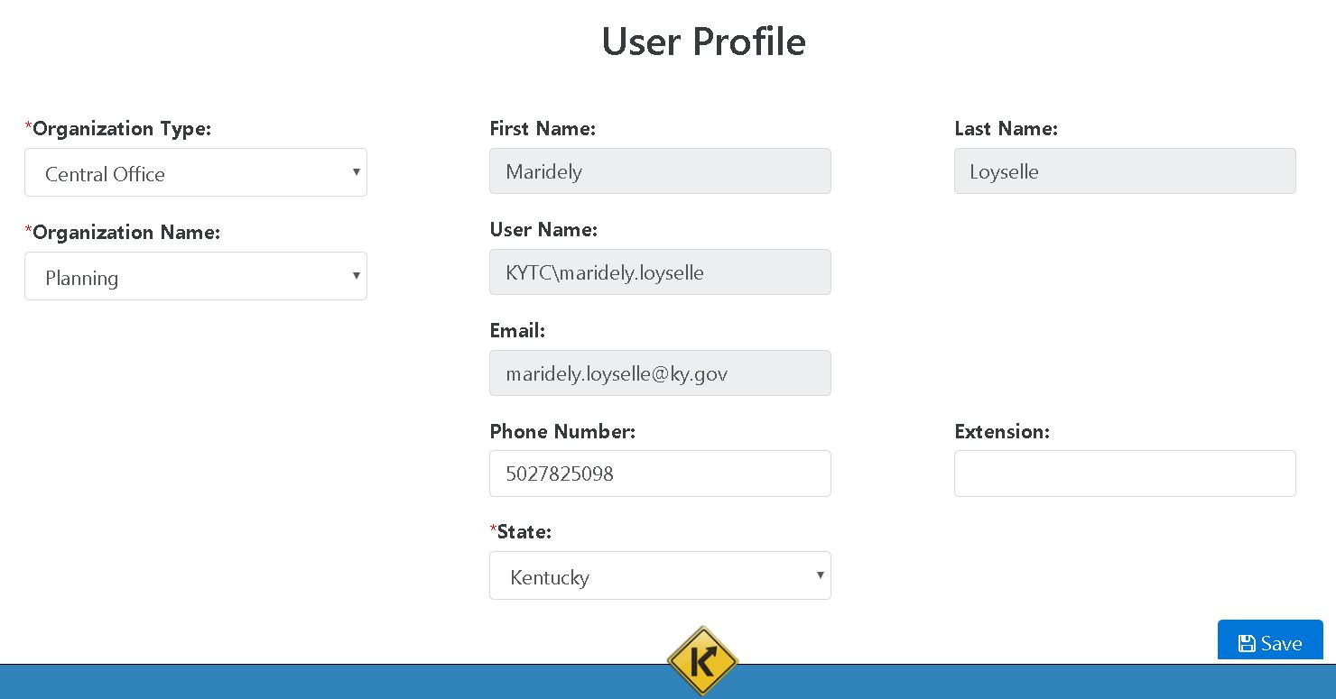

\**Note*: *For KYTC users, if configured properly, your browser will automatically sign you into CHAF. This only applies to KYTC users, Non-KYTC users will need to sign in.*

## Non-KYTC Users Initial Access Request

The process to request access for all Non-KYTC users is as follows:

1. All Non-KYTC users will need to set up a Kentucky Business One Stop (KYBOS) account prior to requesting a CHAF user account. Copy/paste or enter the link below in your browser.

**Non-KYTC Users Link:** [**https://onestop.ky.gov/Pages/default.aspx**](https://onestop.ky.gov/Pages/default.aspx)

1. The KYBOS Service Portal will open (See Figure 2). Click the One Stop Business Services tab in the lower left of the webpage.

**Figure 2 - KYBOS Service Portal**



1. Select do not have a user account, click here to create one link on the right side of the webpage (See Figure 3).

**Figure 3 - Create KYBOS User Account**

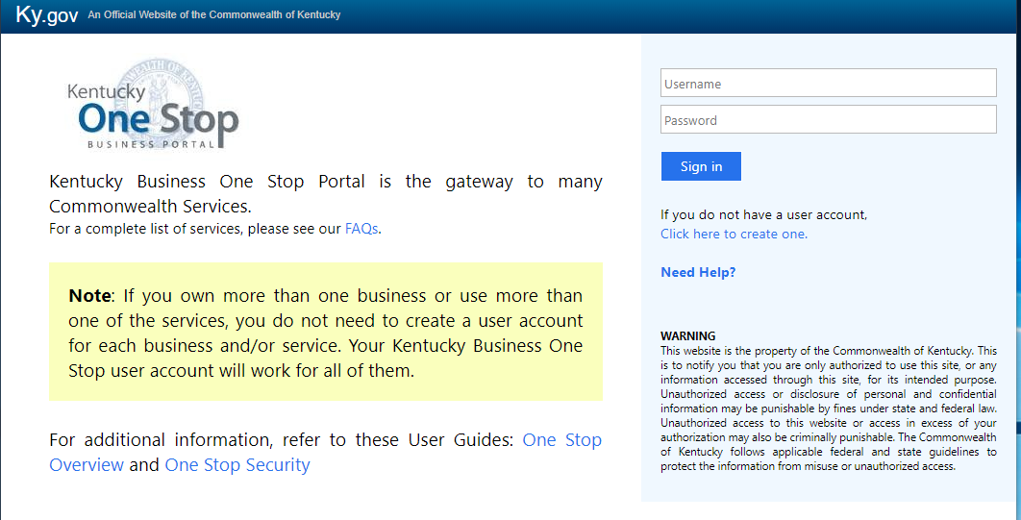

1. All fields designated with an asterisk * must be completed before the **Blue** Create Account button can be selected (See Figure 4). Optional profile information can be entered but is not required to create an account.

**Figure 4 - KYBOS User Profile**

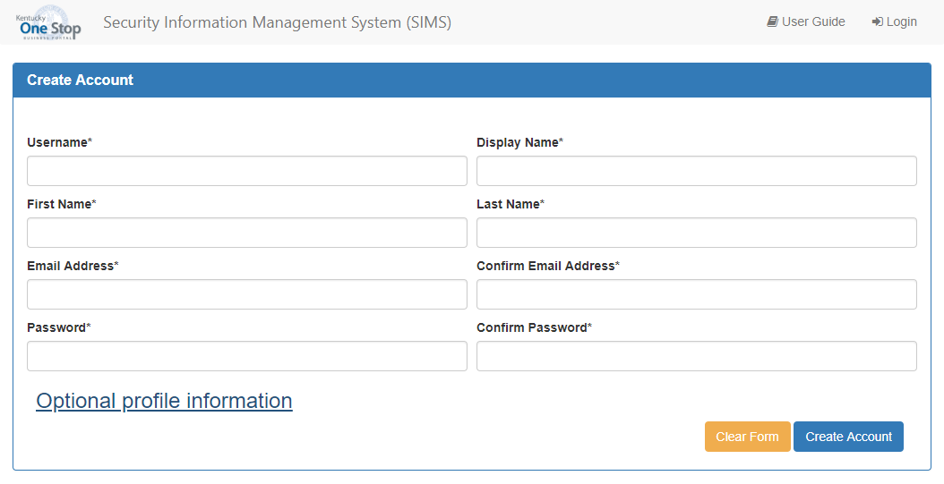

1. KYBOS will send confirmation to the email you provided with instructions to complete your KYBOS account set up.
2. After your KYBOS account has been successfully created you are ready to copy/paste or enter the link below in your browser to request access to CHAF.

**Non-KYTC Users Link:** [**https://apps.transportation.ky.gov/CHAF/Home/Dashboard**](https://apps.transportation.ky.gov/CHAF/Home/Dashboard)**.**

1. The User Profile window will open (See Figure 1). Enter your information in the User Profile boxes, making sure all fields are complete. Press the blue save button.
2. After the User Profile is completed and saved, send an email to the KYTC Central Office CHAF Program Manager stating your User Profile has been submitted and is ready for review.
3. A notification of approval or denial will be sent via email by the CHAF Program Manager.
4. When CHAF authorization has been approved, access to CHAF can be obtained by clicking the link in the authorization email or using the link in step 6 above.

# CHAF’S MENUS

## Menu Bar

The menu bar includes links to Home, Admin, Report and User Guide (See Figure 5).

**Figure 5 - Menu Bar**

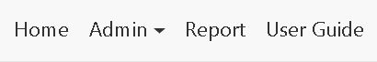

Home will return you to the main dashboard. Here you can search, filter, sort and navigate CHAF projects. CHAF will keep your search settings active until your logout of CHAF.

Admin provides all users the ability to update their user profile. It also provides access to other administrative functions for authorized users like (i.e. Manager Users, Maintain Exception List, Type Table Management and SHIFT Cycle) (See Figure 6).

**Figure 6 - Admin Menu**

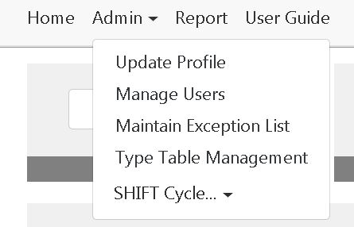

*Report* provides the ability to request a summary page report for a group of projects. Selecting the menu item will display the following screen where the user can set filters to determine which projects are included in the report (See Figure 7).

**Figure 7 - Project Report**

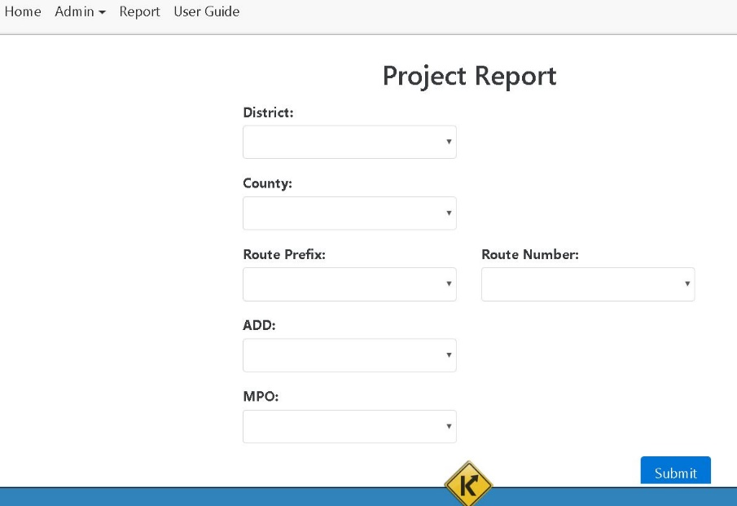

*User Guide*provides a link to this PDF guide of the CHAF website. Or the User Guide can be accessed by copy/paste or entering the link below in your browser (See Figure 8).

**CHAF Users Guide Link:** <https://apps.intranet.kytc.ky.gov/CHAF/Home/OpenUserGuide>

**Figure 8 - CHAF User Guide**

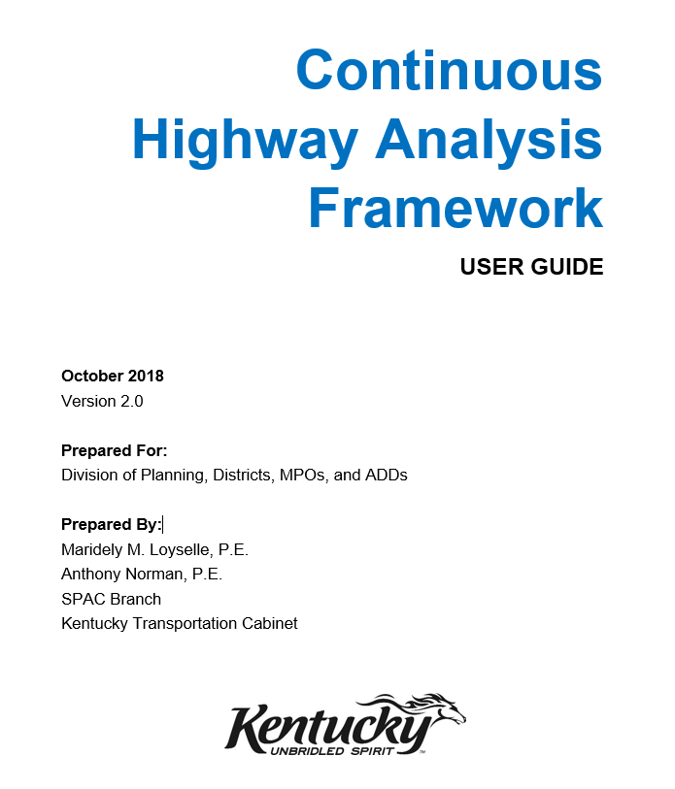

## Update of User Profile

All users may update their phone number, extension, and state at any time (See Figure 9). Organization information can only be updated by authorized users whom have been given authority by the Central Office CHAF Program Manager during the initial authentication and authorization phase.

Procedure to update to user profile:

1. Click the Admin tab on the menu bar (See Figure 5 & 6).
2. Then select Update Profile.
3. Update the user profile field(s) you want to bring up to date.

**Figure 9 - Editing User Profile**



## Dashboard

The dashboard is the principle work area for CHAF users. It provides a set of dashboard widgets customized to the user and their permission level within the CHAF system. Some widgets, such as those that support the SHIFT cycle, only appear during certain time periods. These time sensitive widgets are controlled by the Central Office CHAF Program Manager (See Figure 10).

**Figure 10 - CHAF Dashboard**

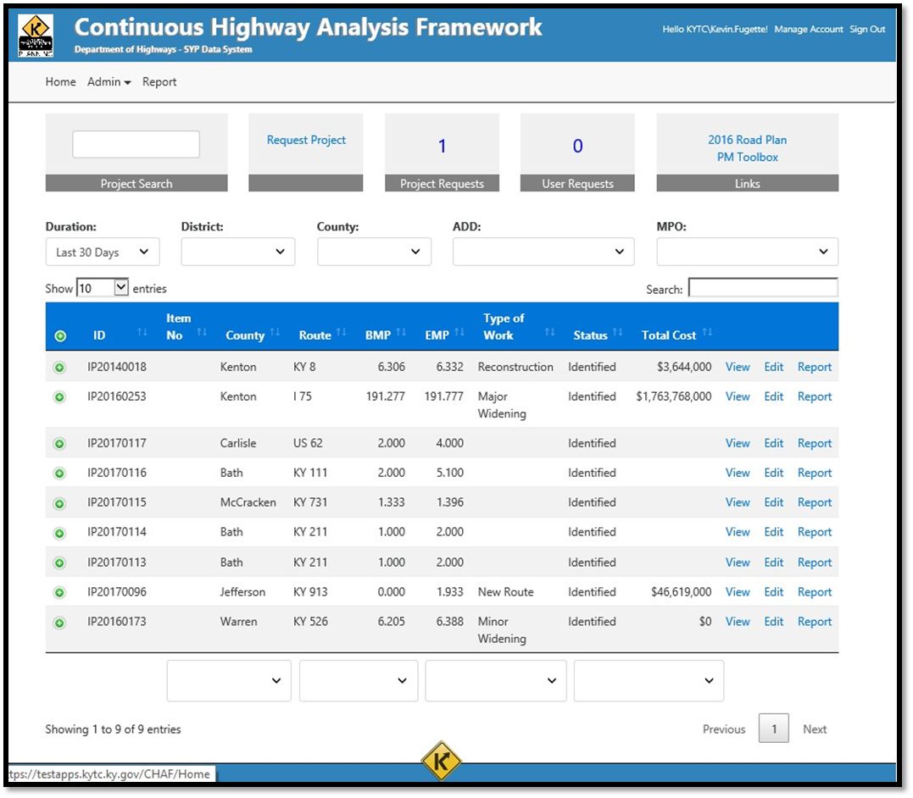

## Dashboard Widgets

The ability to add/remove a widget link is managed by Central Office.

## Project Search

The ability to search for project is fundamental to locate specific projects. The project search box is located in the top left side of the dashboard (See Figure 11).

**Figure 11 - Project Search Box**

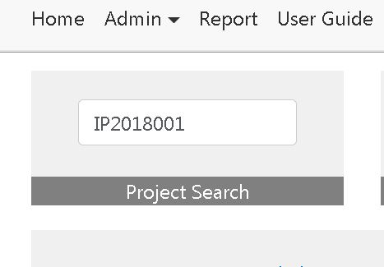

## Request Project

The Request Project widget gives all users the access to request a project be created in CHAF. When a project request is created, Central Office will research that request and determine if it should be added to an existing project or is a new project (See Figure 12).

**Figure 12 - Request Project**

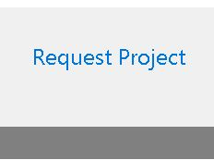

## Project and User Requests

These widgets only appear for authorized users. It notifies these users of when they need to review a request of a CHAF project, or review a CHAF access request and provides them access to it (See Figure 13).

**Figure 13 - Project and User Request**

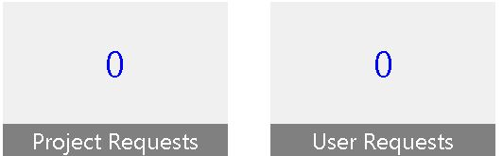

## Links Widgets

The links widget is an easy way to access the current Six Year Enacted Plan (SYP) and the Project Managers Toolbox, both are available to all users (See Figure 14).

**Figure 14 - Links**

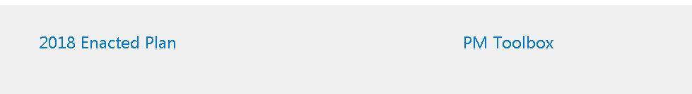

## SHIFT Cycle Widgets

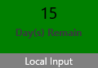The SHIFT Cycle widgets only appear during the period specified for each phase of the SHIFT cycle; Sponsorship, Validation, and Local Input. The widgets change color as they near the end of their period. They start green, turn yellow when 25% of the period remains and turn red for the last 10% of the remaining period. During the active phase of the widget, users can click on the widget icon to be redirected to support material for each widget phase cycle. After each widget phase has ended, the widgets will display closed and the link will be deactivated by Central Office (See Figure 15).

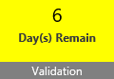

**Figure 15 - SHIFT Status Widgets**

## Project Grid

Projects are shown in the dashboard in the form of a table. The table contains a blue rectangle which lists the projects’ CHAF ID, Item no., County, Route, Beginning and End Mile Point (BMP, EMP), Type of Work, Status and Total Cost. Table headers located near the top of the Project Grid (circled in red) and a set of four drop down menu boxes found near the bottom (circled in yellow) will allow users to filter and sort the list of projects displayed in the table (See Figure 16).

It is important to understand the search box in the project grid only applies to the projects shown in the grid. It allows the user to tailor their search to specific features of the project(s).

**Figure 16 - Project Grid**

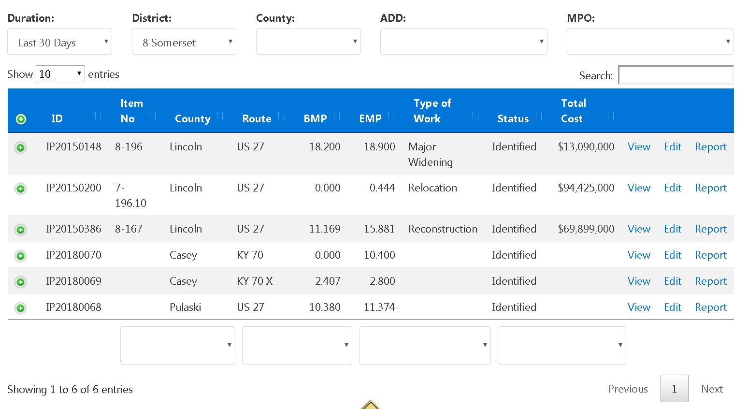

The project grid in the dashboard shows the projects added in the last 30-days as default. However, users have also the ability to choose the last 60 days, last 90 days, last year or all time. The small arrows beside each column title let the user change the order of the project from ascending to descending (See Figure 17).

**Figure 17 - Duration Filter**

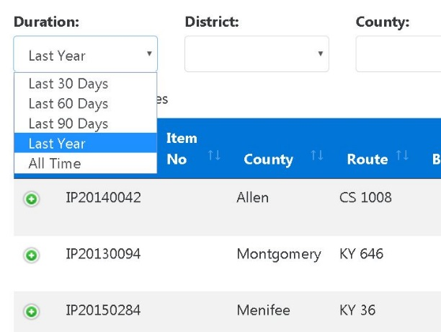

Figures 18, 19 and 20 show the different types of filters available at the bottom of the project grid in the dashboard (See Figure 16 – circled in yellow). The bottom filters allow the user to look up for specific county, route, type of work or projects are active or inactive.

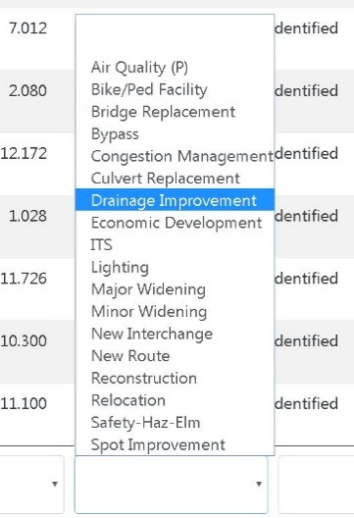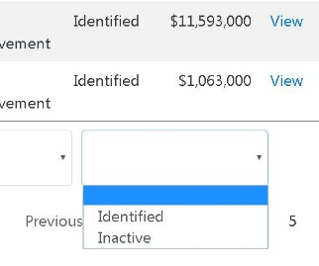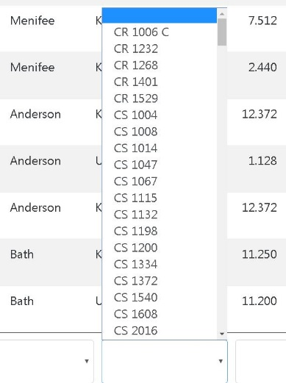

**Figure 20 - Project Status Filter**

**Figure 19 - Improvement Type Filter**

**Figure 18 - Route Filter**

# PROJECT REQUEST

This section will provide you with a step by step guide to request a new project in CHAF.

All CHAF projects must be approved by KYTC Central Office.

## Request Project Procedures

1. On the Home page, next to the Project Search box is the Request Project Widget. Place your cursor over the Request Project and click (See Figure 21).

**Figure 21 - Request Project Link**



1. The Request Project Page will open as shown below. Complete all the project request information and click the blue Submit Request at the right bottom corner of the page (See Figure 22).

**Figure 22 - Request Project Page**

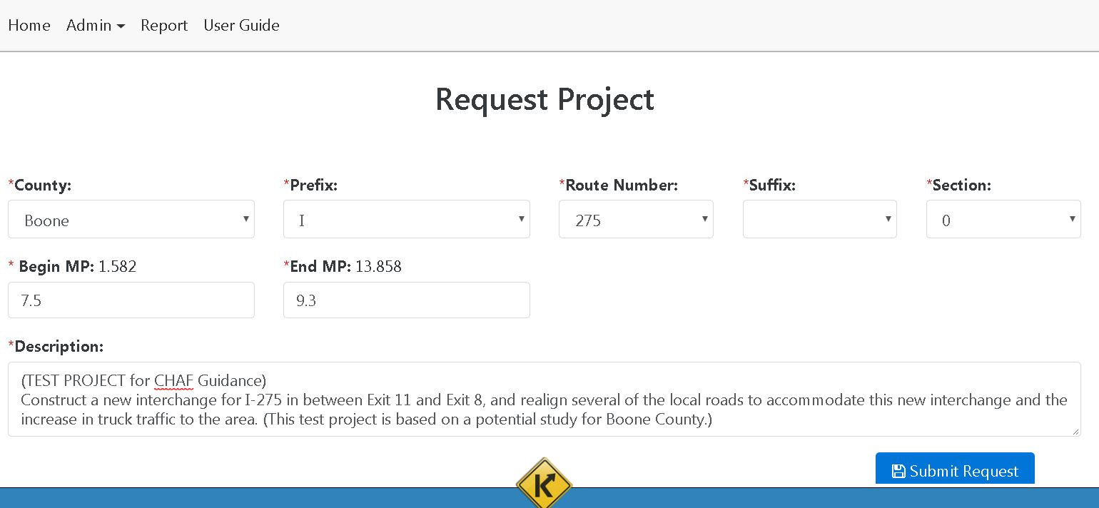

1. After submitting a request for a project please send an email to the CHAF Program Manager notifying them you have requested a project. The CHAF Program Manager then will be able to see in the dashboard a project request is waiting for review and pending approval (See Figure 23).

**Figure 23 - Request Project Page**

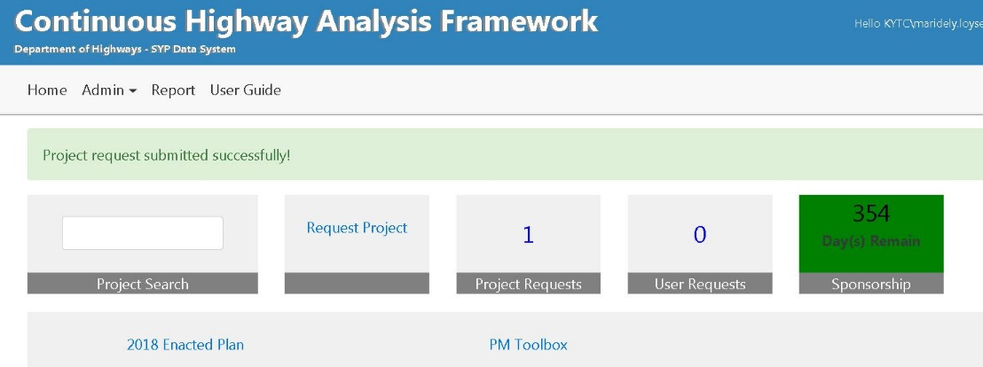

1. The CHAF Project Manager can then access the information regarding the project. The new window will provide the name of the person creating the project, the county, route, beginning and ending mile points, and the description of the project. The CHAF Project Manager will then review and research the project verifying the project request is not a duplicate or in the current Six Year Plan (See Figure 24).

**Figure 24 - Research Project Page**

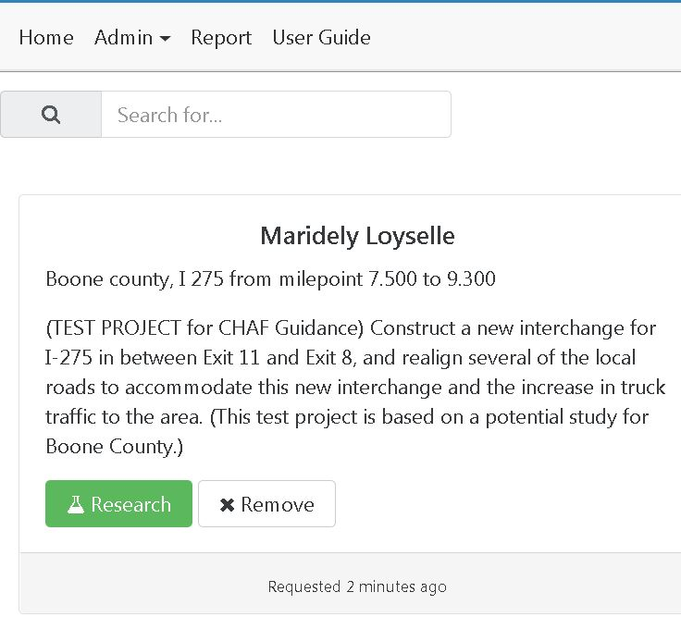

1. The Search Existing Project page verifies a duplicate project is not created in CHAF. Once the project is confirmed, the CHAF Project Manager can authorize the creation of a new project (See Figure 25).

**Figure 25 - Search Existing Project Page**

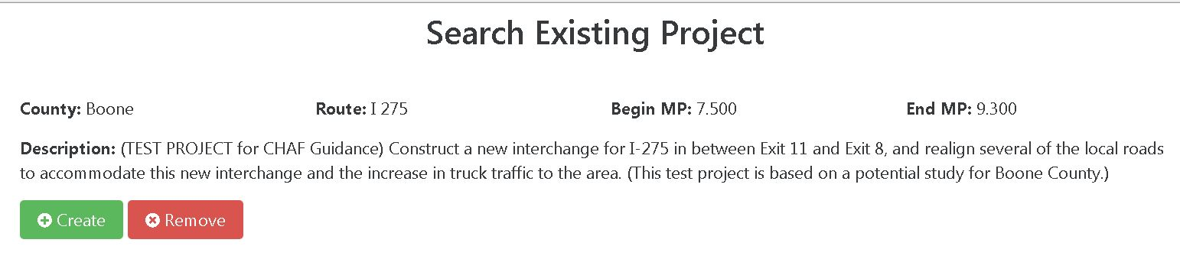

1. An email notification will be sent by the CHAF system notifying the user who requested the project that the project has been successfully created. The email will contain the CHAF ID number of the project (See Figure 26).

**Figure 26 - Email Confirmation of New Project**

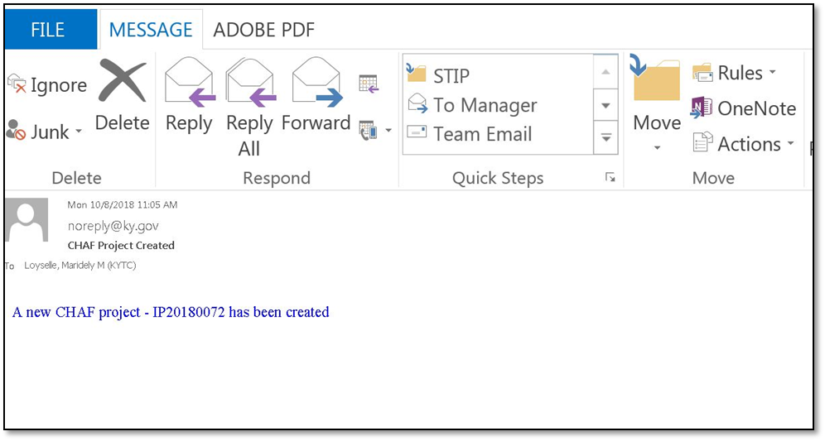

1. After the project is created, the user is responsible to access CHAF and complete all the project details in the Edit Project Page**.** The user must provide purpose, need, estimate, drawing of the route, uploaded attachment(s), characteristics etc. Project information will be used in the SHIFT prioritization process. Complete instructions to edit a project are on the following page.

# EDITING PROJECTS

All CHAF projects must be continuously updated and edited throughout the life of the project to keep the project current and accurate. This section discusses the step by step process of editing or modifying a project.

## Edit Project Procedure

1. In the dashboard (See Figure 10) locate your project by using your CHAF ID # of the project in the Project Search box or by using the project table filters (See Figure 16).

***Hint****: If the project you are looking for was recently created in CHAF, you should be able to find it at the top of the project table with the last 30-day filter. If your project is older than 30-days you may need to change the duration filter setting (See Figure 17).*

1. Once the project is displayed in the project grid, click on the Edit link on the far right of the project row (See Figure 27).

***Note: If you are unable to edit the project, then you do not have permission to edit it. To request authorization to edit projects, contact the Central Office CHAF Program* Manager.**

**Figure 27 - Edit Project**

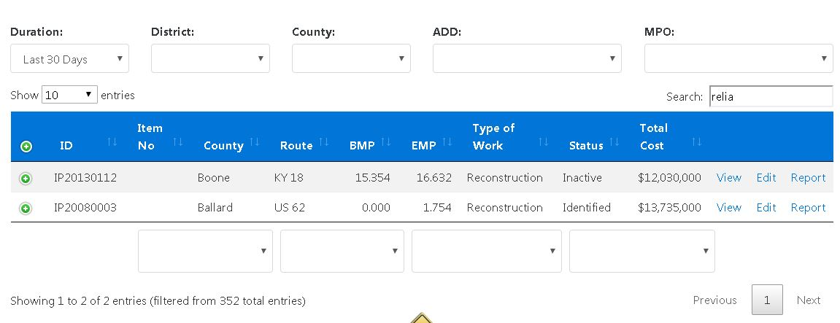

1. The Edit Project page contains a menu on the left hand side with four tabs; Home, Need, Map and Attachments. The default tab for the Edit Project page is Home, here you will find the project ID, status, SYP item numbers, description, type of work, review comments, location and bridge details. KYTC will automatically upload the location and bridge information details for you into the CHAF system. To see location and bridge data simply select the Location or View Bridge Details icons (See Figure 28).

**Figure 28 - Edit Project Page**

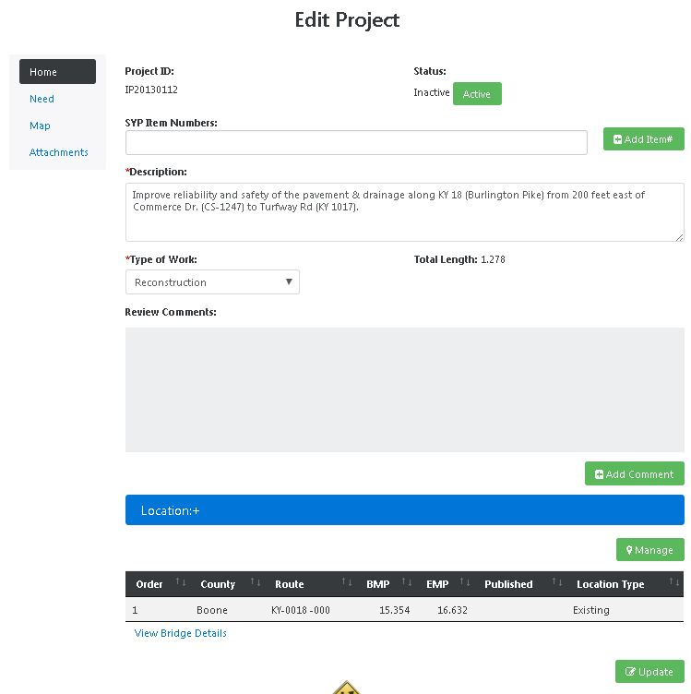

## Project Status

1. Each project currently has an identified (active) or inactive status within the CHAF system. In the future CHAF will strive to implement higher-level status indicators that will describe in greater detail what phase the project is currently in or has transferred out or into.

The current statuses being implemented for the CHAF program are:

|  |  |
| --- | --- |
| **Identified** | The initial state of all projects – an identified need. |
| **Inactive** | Manually set for a project that is no longer being considered or has been cancelled. |

As the Highways Projects program progresses, additional future statuses and revised current status such as the following may be implemented:

|  |  |
| --- | --- |
| Identified | A project that will be scored by the SHIFT Process. |
| Scheduled | Any project included in the six year plan but has no authorized funding. |
| Started | A six year plan project that has authorized funding  A separate indicator depicting the status of each phase **(P,D,R,U,C) will also be displayed. |
| Stalled | A project that was Started, but has stopped for any reason, yet is still an active project that KYTC wishes to keep active.  A separate indicator depicting the status of each phase **(P,D,R,U,C) will also be displayed |
| Let/Awarded | A project that is in the Letting/Award process. |
| Construction | A project that is under construction.  Additional indicators based on data from Site Manager may be displayed |
| Complete | A project that is completed and all ROW is clear. |
| Inactive | A project that is inactive for any reason, or needs to be deleted |

**(P,D,R,U,C) = Planning Phase, Design Phase, Right-of-Way Phase, Utility Phase, Construction Phase

## Project Location

1. Review the location of your project by selecting the blue bar labeled Location. To edit the location of your project click on the green Manage button in the lower right side of Location section (See Figure 29).

**Figure 29 - Edit Project Location**

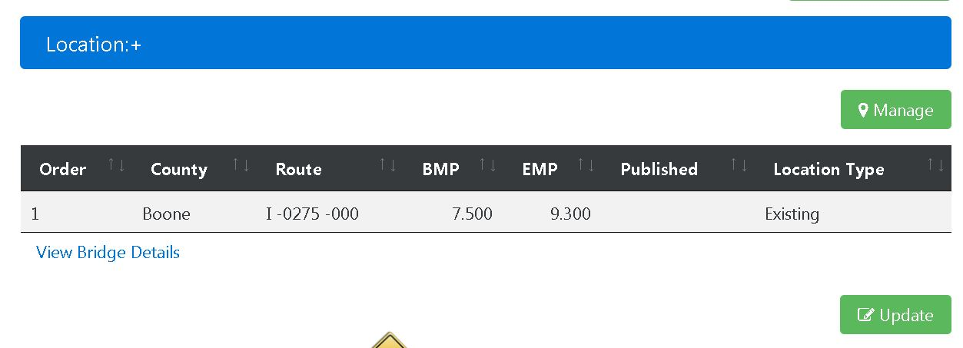

1. The Map page will open (See Figure 30) and will display a table header allowing the user to select the order of the route you wish to update by selecting Edit on the lower right of your screen.

**Figure 30 - Map Edit Project Page**

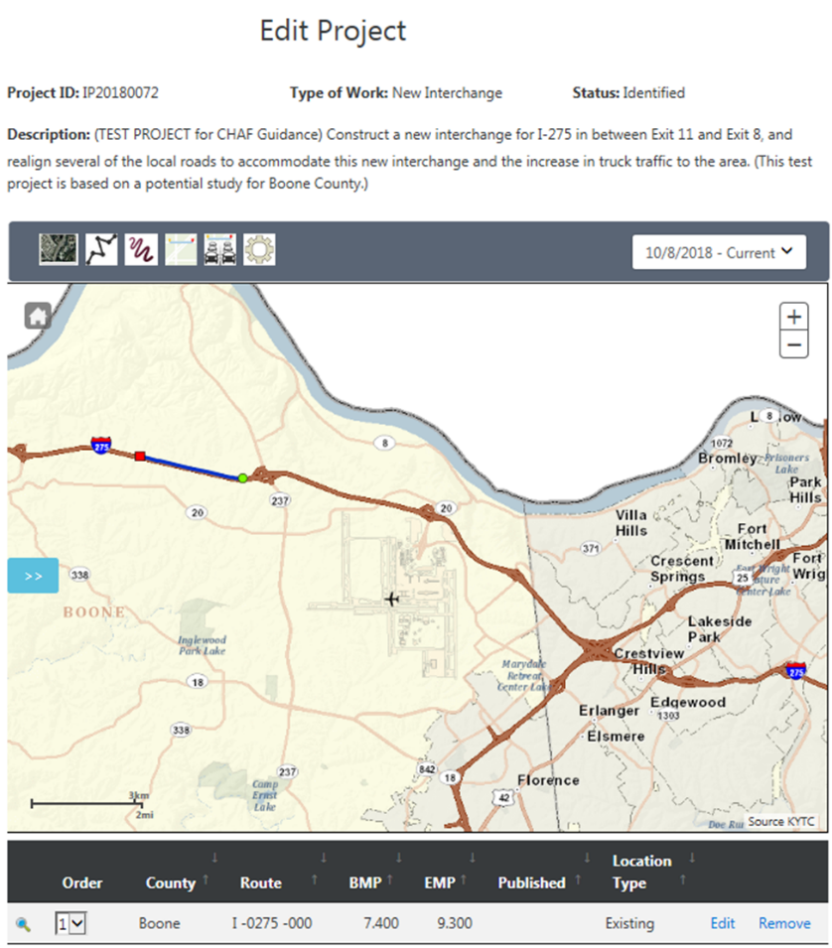

*Note: The Route Order can vary from a single route to several routes depending on the scope of the project. Each route would need to be edited separately if different revisions to multiple routes are required.*

1. The Location Edit Page will the user access to change the beginning mile point, ending mile point and location type. Press the green Save button to save/update your changes (See Figure 31).

**Figure 31 - Edit Location Page**

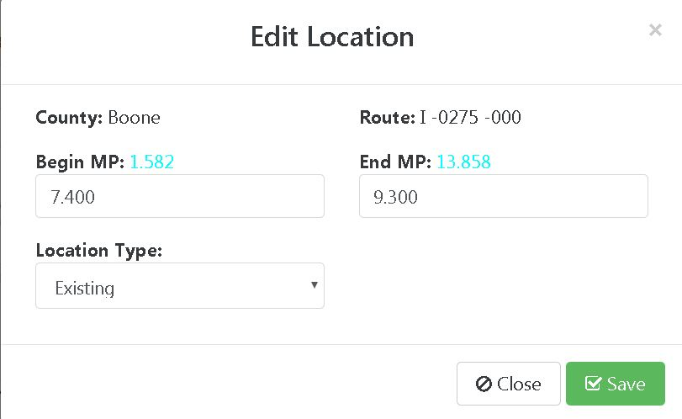

## Bridge Details

1. To View Bridge Details (if a bridge(s) are located on a route within your project area) place your curser on View Bridge Details in the lower left of Edit Project Page and select. The Location section may need to be expanded if the View Bridge Detail icon is hidden. Simply select the Location+ in the blue rectangle and the View Bridge Details will appear (See Figure 32).

**Figure 32 – View Bridge Details**



1. The Bridge Details link is a quick way to identify what bridge(s) are within your project area, the route they reside on, the mile point location, Bridge ID, On/Under, Sufficient Rating and Deck Rating. As stated earlier, CHAF will automatically populate this information if a bridge is on a route within your project area (See Figure 33).

**Figure 33 - Edit Bridge Details**

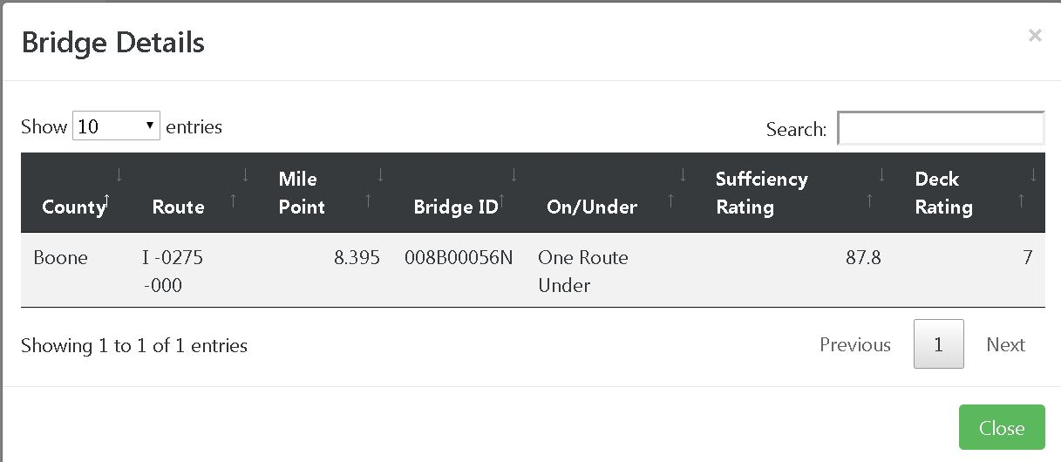

# PURPOSE AND NEED

1. Under the menu on the left side of the Edit Project Page click the Need tab (See Figure 34). This tab outlines the Area Development District (ADD) or Metropolitan Planning Organization (MPO), the purpose, need, estimates and characteristics of the project. **Estimate and characteristics sections will be described in greater detail in the following two sections.

***Hints****: If an ADD is selected then a MPO cannot be selected, and vice versa. This means only one ADD or MPO can be the requestor of the project. If an MPO and an ADD both request the same project then CHAF will verify a duplicate project has been requested and the CHAF Program Manager may deny the duplicate request.*

*Purpose and Need are critical components of your project request. Every effort must be made to provide a complete and well informed Purpose and Need.*

*The purpose and need of the project must be provided. You cannot submit or save changes without providing the purpose and need.*

In the Completed By box make sure to include your name, title and organization.

**Figure 34 - Purpose and Need Tab**

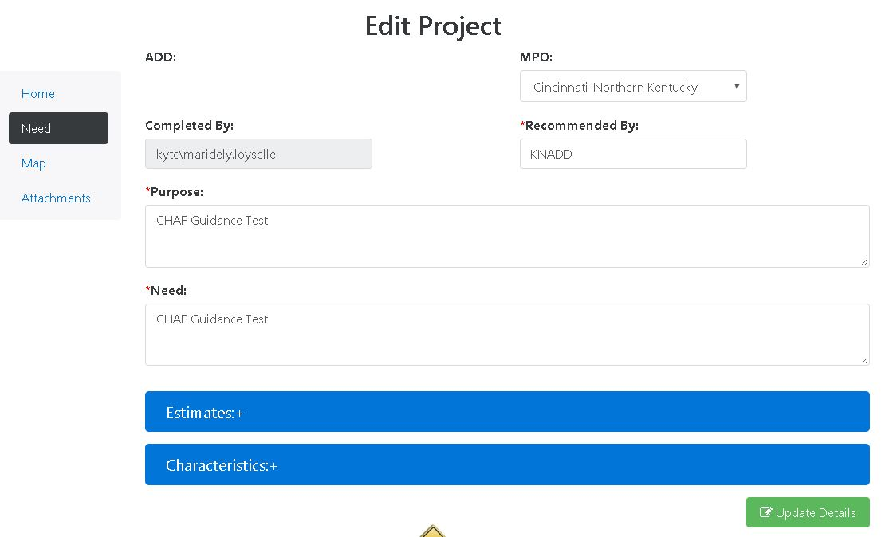

## Cost Estimate of Projects

1. The Estimates+ section allows the user to provide preliminary cost estimates for each phase of your project. You can expand the Estimates tab by selecting the blue Estimates rectangle (See Figure 35).

**Figure 35 - Project Estimates**

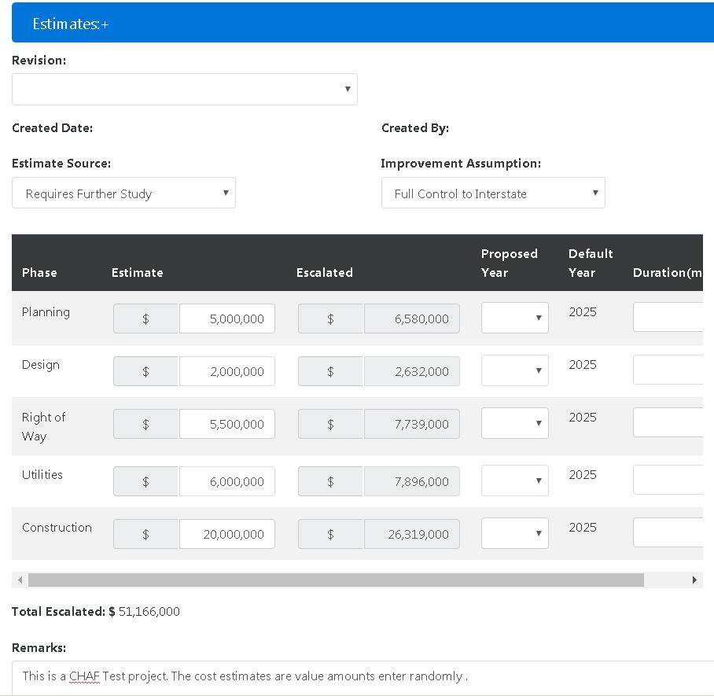

The estimate source provides several options outlining what the estimate is based on (See Figure 36).

**Figure 36 - Estimate Source**

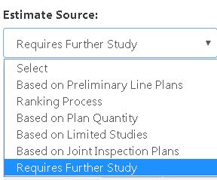

The improvement assumption selection is the district’s current plan to solve the need of the project (See Figure 37). In the definitions portion of this guidance manual are a list of Improvement Type descriptions to help the user select the most relevant Improvement type for their project. After all estimate costs are entered, the estimate source and Improvement Assumption (also known as Improvement Types) fields are complete, save your data by selecting the green Update Details icon on the bottom right corner of the Edit Project page (See Figure 34).

**Figure 37 - Improvement Assumption**

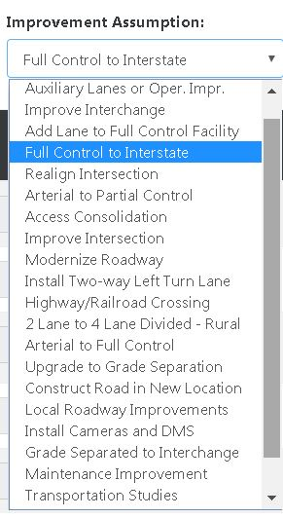

The project improvement assumptions are used to make possible calculation later in the SHIFT process. Therefore, the selection of improvement types should not be left in its default selection of “other improvements”.

## Project Characteristics

1. Select the blue Characteristic bar to provide specific characteristics of your project.

(See Figure 38, 39, 40, 41)

This includes:

* Existing Studies: Any existing studies completed on this project? If so please attach them.
* Proposed Access Control: What type of access control is planned for the project?
* Proposed Lane Width: What are the proposed lane widths for the project?
* Proposed Number of Added Lanes: How many lanes are going to be added to the project?
* Proposed Median Type: What is the proposed median type for the project?
* Proposed Shoulder Type: What is the proposed shoulder type for the project?
* Proposed Shoulder Width: What is the proposed shoulder width?
* Project may require additional Right of Way?
* Project may require relocation?

**Figure 38 - Project Characteristics**

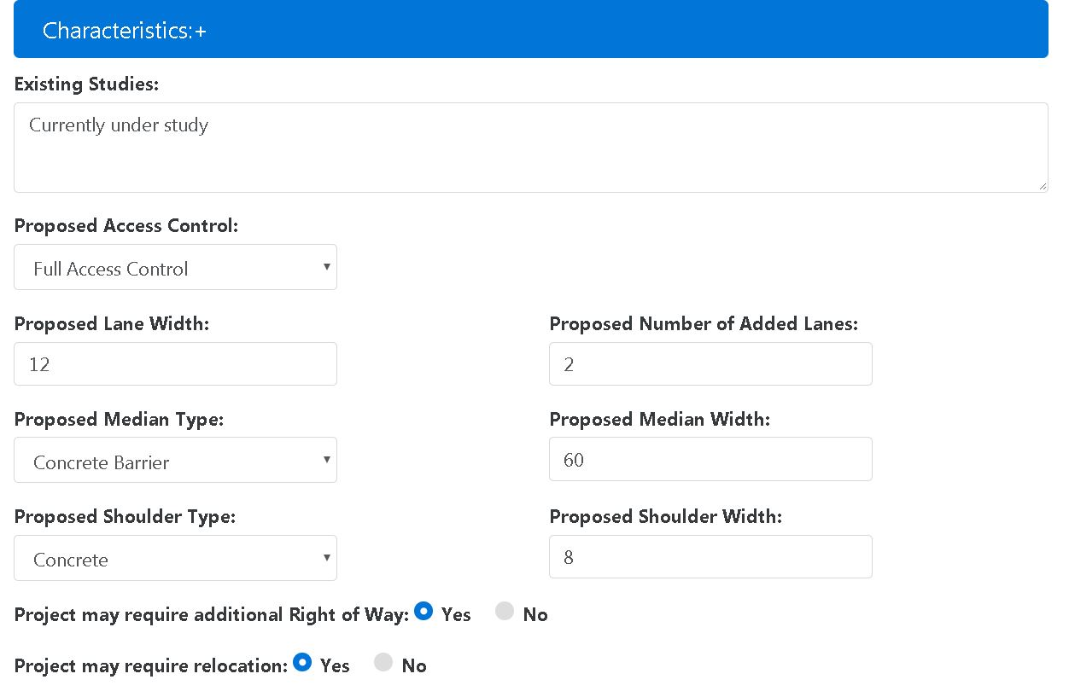

* Which of the following would this project support?
* Which, if any, major points of interest would this project increase connectivity with?

**Figure 39 - Project Characteristics**

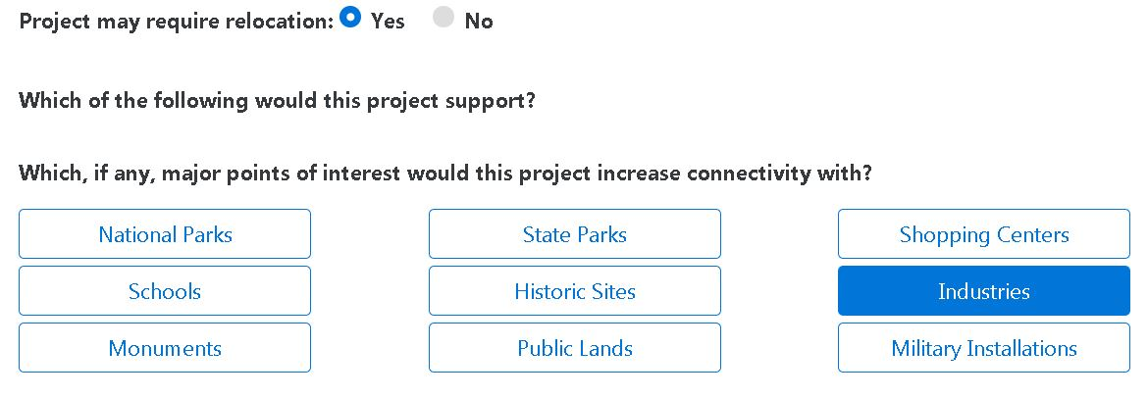

* Is there a likelihood this project could accommodate any of the following?
* Is there a likelihood for this project to have any of the following socioeconomic impacts?

**Figure 40 - Project Characteristics**

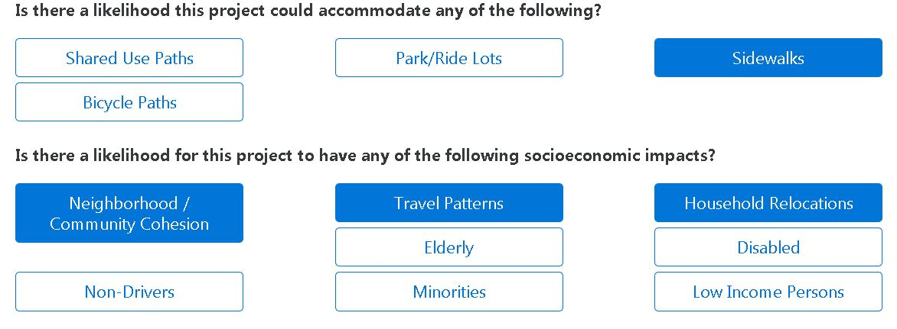

* Is there a likelihood for this project to affect any of the following environmental concerns?
* Which, if any, utilities would be affected?

**Figure 41 - Project Characteristics**

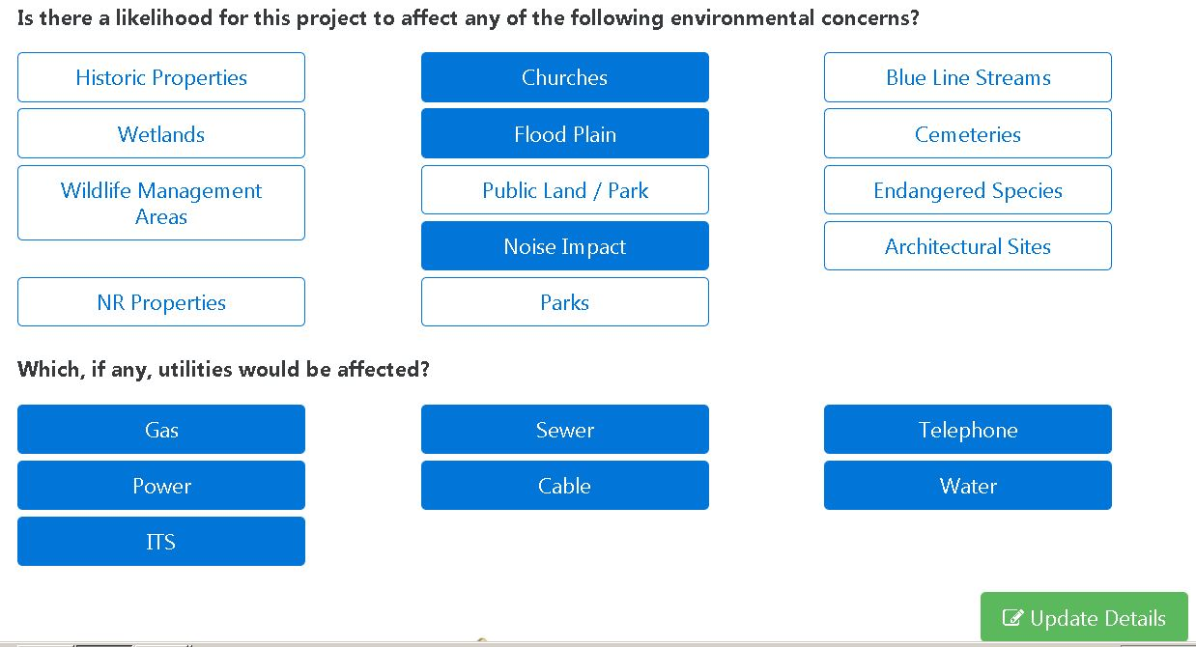

1. After you have filled in or changed the Project Characteristics information select the green Update Details button at the bottom of the page (See Figure 41 above). At the top of the page a dialog box will show that your project update was successful (See Figure 42).

**Figure 42 - Project Updated Successfully**

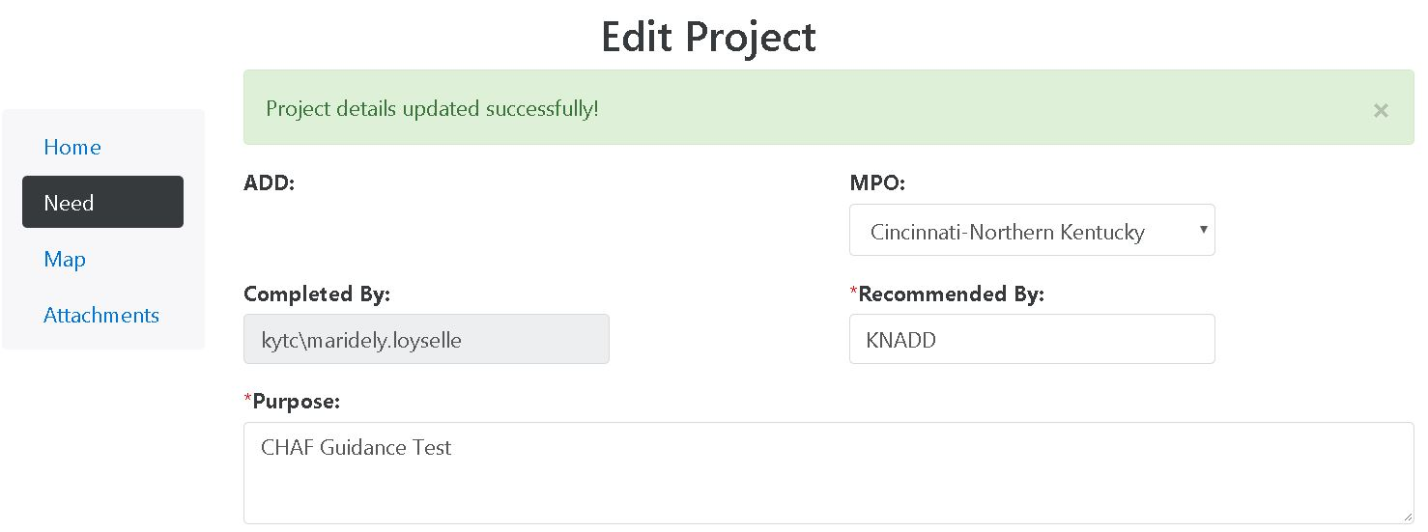

# PROJECT MAPS

1. The User may access their Project Map two ways:

On the Edit Project page (See Figure 27 & 28), select Map (See Figure 43 below, red circle).

On the Edit Project page (See Figure 27 & 28), click to expand the blue Location section then select the green Manage box (See Figure 29).

**Figure 43 - Access the Project Map**

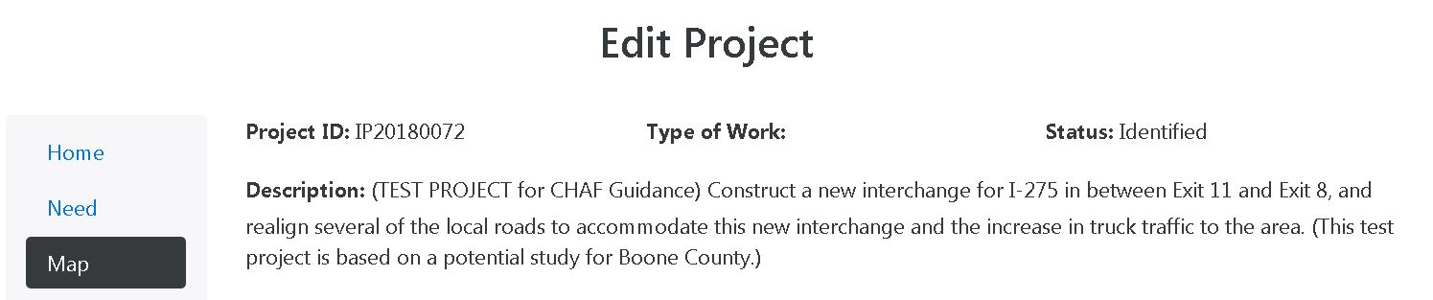

The Project ID, Type of Work, Status, and Description are listed at the top of the webpage (See Figure 43). If the Type of Work, Status, and Description require editing the user must go back to the Edit Project Home page and make corrections there (See Figure 43 above, green circle). The Type of Work is a designation or Category use for the Six-Year-Plan.

1. The map tools are located on the top left of the page (See Figure 44 red circle). The current version and any updates to the map will allow the user to look at the different revisions to the project map that have been made (See Figure 44 Green Circle & Figure 45).

**Figure 44 - Project Map Tools**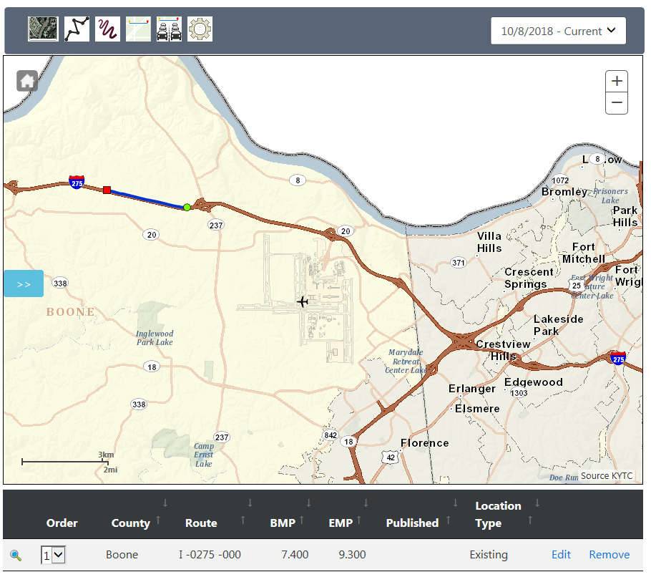

**Figure 45 - Project Map Revisions**

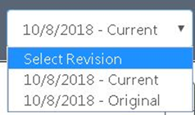

## Edit Mile Points

1. 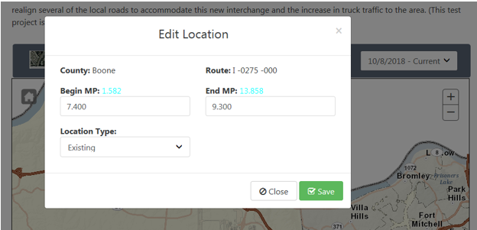Click the edit button (See Figure 44 orange circle), which is located on the bottom portion of the map, which lists the route(s). The following screen will open (See Figure 46).

**Figure 46 - Edit Map Mile Points**

1. In the Begin MP box and the End MP box change the mile points to the desired mile points. *Note*: The beginning and ending mile points of the road are in blue on this page and if you zoom close enough on the map you can see the mile points as well.
2. After you are done changing the mile points, click the green save button and the screen will automatically close.

*Note: It is very important to push save in CHAF if you change anything. CHAF does not automatically save added information or changes until the user selects the save/update button.*

## Location Type

The route edit page is where you can change the route based on its location type. There are three location types:

* Existing: Is an existing road, ramp or intersection that is going to be worked on or is important component of the project
* Impacted: Is an existing road whose traffic flow will be affect by the addition of a new route
* Proposed: Is a new route, ramp, or intersection that is going to be created by the project

## Map Tools



The map tools are used to add, modify or edit the route(s) in the project map.

Changes from a base map to an aerial map, and vice versa.

Proposed allows the user to draw in a proposed new or realigned route, ramp, intersection, or interchange. This tool only allows the user to draw in straight lines.

Free hand proposed allows the user to draw in a proposed or realigned route, ramp, intersection, or interchange. This tool allows the user to free hand draw in the proposed.

Existing allows the user to highlight the existing route(s), interchange(s), ramp(s), or intersection(s) that are going to be affected by the project.

Impacted allows the user to highlight the impacted route(s), interchanges, ramps, or intersections that are going to be affected by the project map tool.

Settings allows the user to change the setting for the map tools. When it’s selected the Map settings screen opens (See Figure 47).

**Figure 47 - Map Settings**

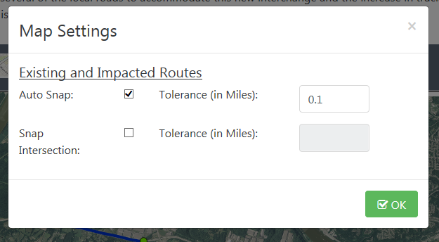

The Maps settings allows the user to change the snaps for the existing and impacted routes. In addition, it allows the user to adjust the route tolerance.

## Cardinal Vs Non-Cardinal

**Figure 48 - Cardinal Direction**

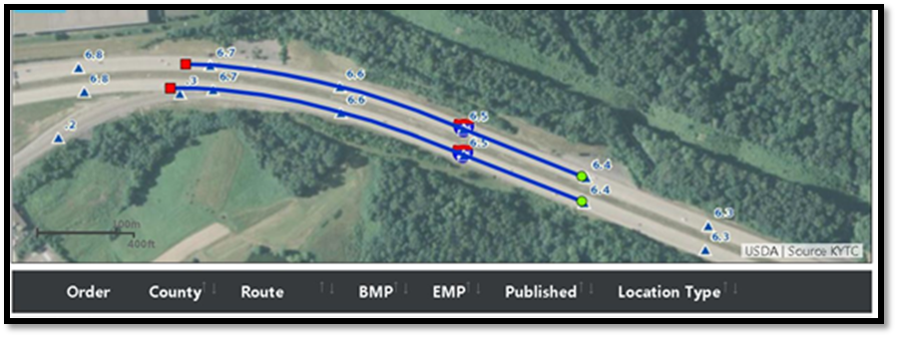

When selecting an existing or impacted route the cardinal direction of the route **must** be selected. The cardinal direction is determined by observing which side or direction the mile points increase on a route. Therefore decreasing mile points would indicate a non-cardinal direction. SHIFT data is tied to the cardinal direction of our roadways, therefore the cardinal direction must be selected (See Figure 48). However, Cardinal direction does not apply to the Bridge Details information.

Another way to verify you have selected the cardinal direction is by checking the last three digits in the route identifier on the bottom of the map page (See Figure 49).

* 000 is the **cardinal direction**
* 010 is the non-cardinal direction

**Figure 49 - Cardinal Direction Route Identifier**



In the image below (See Figure 50) the cardinal direction was chosen for Fayette County, while the non-cardinal direction was chosen for Woodford.

**Figure 50 - Cardinal Direction Example**

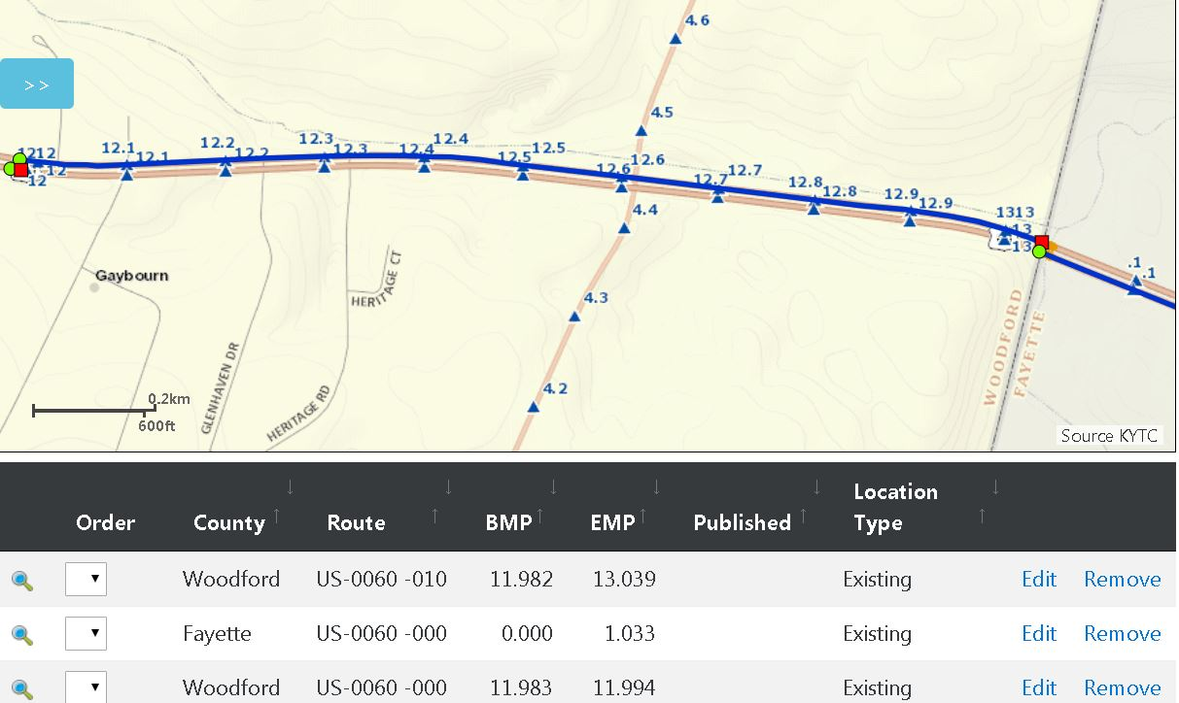

## Project Across a County Line

To draw a route across a county line you have to break the route into segments starting or ending at the county line. For each county, the user will have to draw in the portion of the route that exists or is impacted in each county (See Figure 51).

**Figure 51 - Route over a County Line**

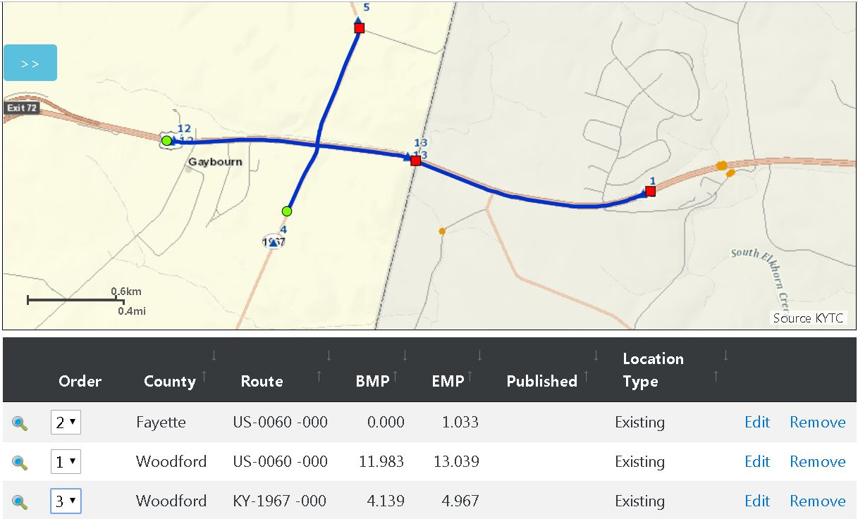

## Route Order

**Figure 52 - Route Order**

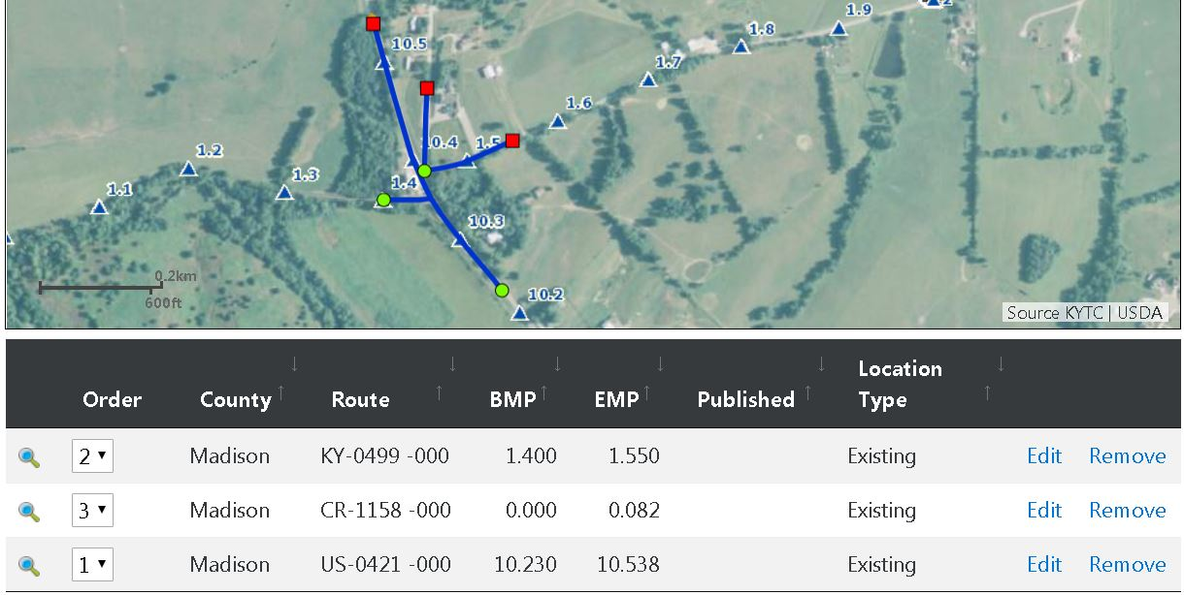

Overall, the order of roads is the following:

1. Existing Main Line:
   * Route order: Interstate, US, KY, County, then City streets/routes
   * If interchange project: Interstate, then ramps that connect to it, then other Interstate, US, KY, County, then City streets/routes
2. Existing Secondary:
   * Route order: Interstate, US Route, KY, County, then City streets
3. Impacted
4. Proposed

The order of the routes is very important. Route order allows SHIFT to process data for the main route first, then continues to layer data into the SHIFT system based on a hierarchy of route impact (See Figure 52).

# ATTACHMENTS

Click on the Attachment Tab on the left side menu of the Edit Project Page to upload files into your project. To add a file, click in the box with the message “drag and drop here or click to add specific files” (See Figure 54 & 55).

**Figure 53 - Uploading Attachments**

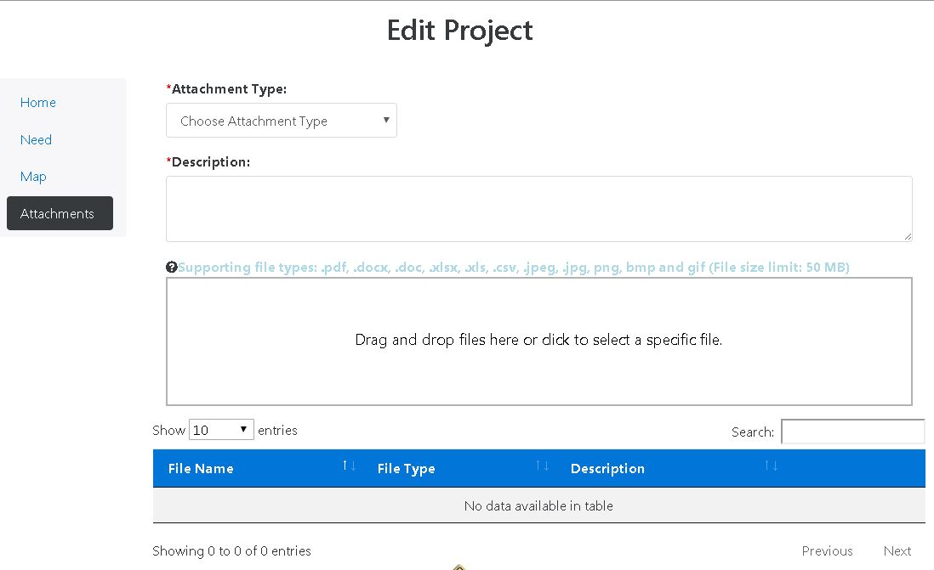

**Figure 54 - Attachment Example**

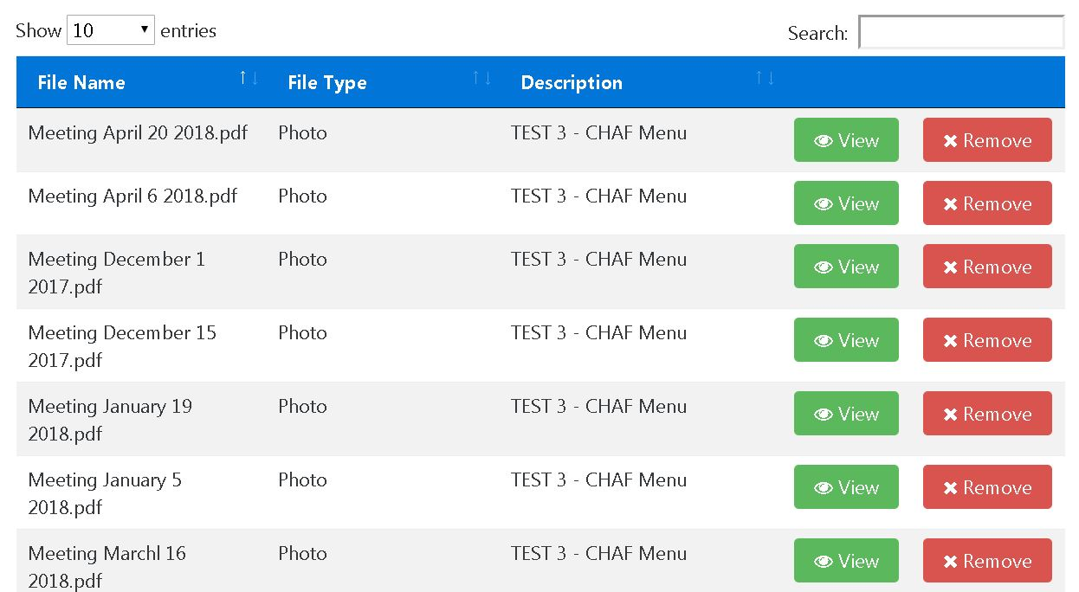

*Note: Only pdf, doc, docx, xls, and xlsx files can be attached.*

# PROJECT REPORT

There are two ways to obtain a project report.

1. On the home page main tab there is a link to the reports (See Figure 56 red circle).
2. For each project in the project table there is a link to the reports (See Figure 56 green circle).
3. Fill in the fields in the Project Report Window with your projects information (See Figure 57).

**Figure 55 - Project Report from Home Page**

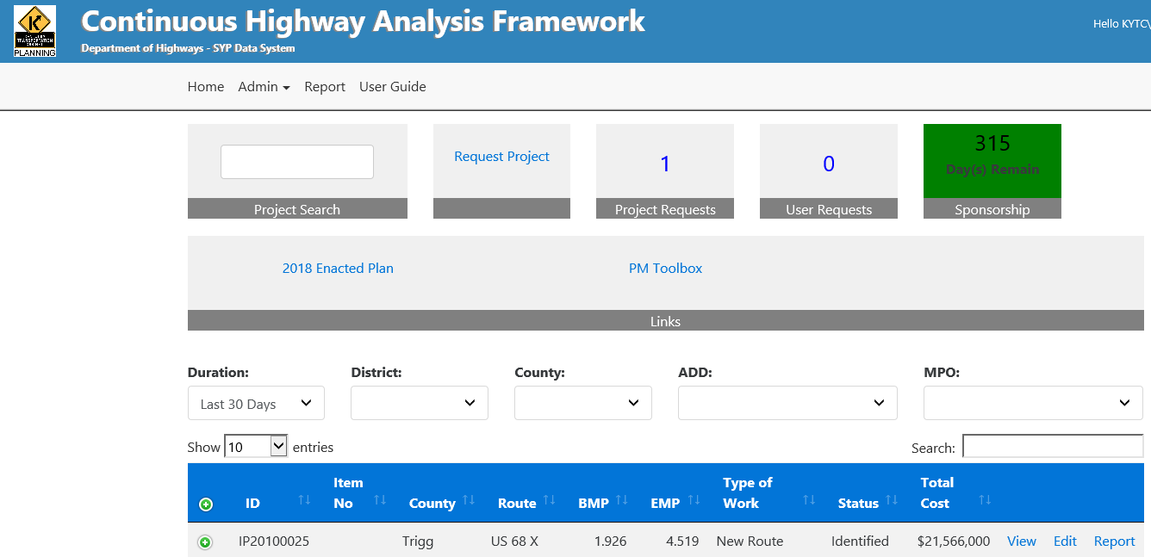

**Figure 56 - Project Report**

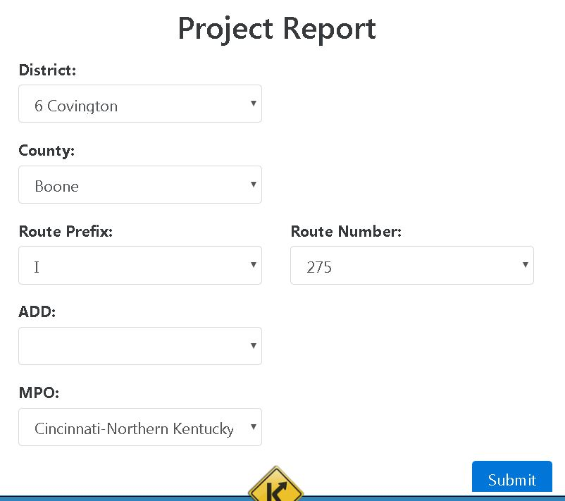

## Report Summary

Below is an example of a report summery of a CHAF project (See Figures 58 & 59).

**Figure 57 - Project Report Example**

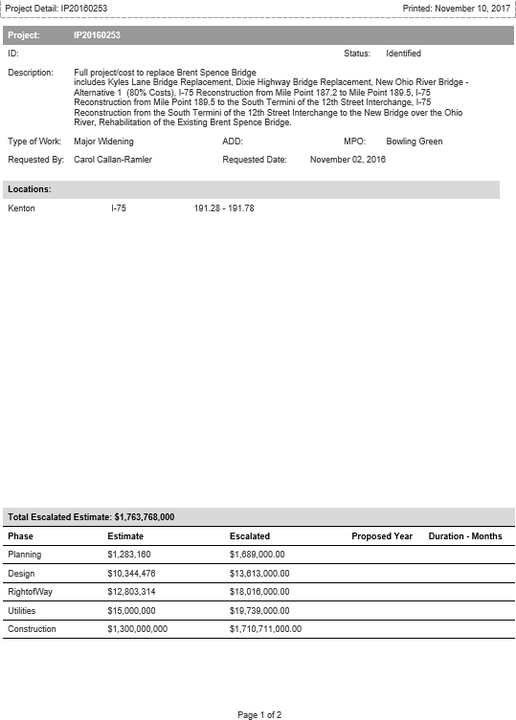

**Figure 58 - Project Report Example**

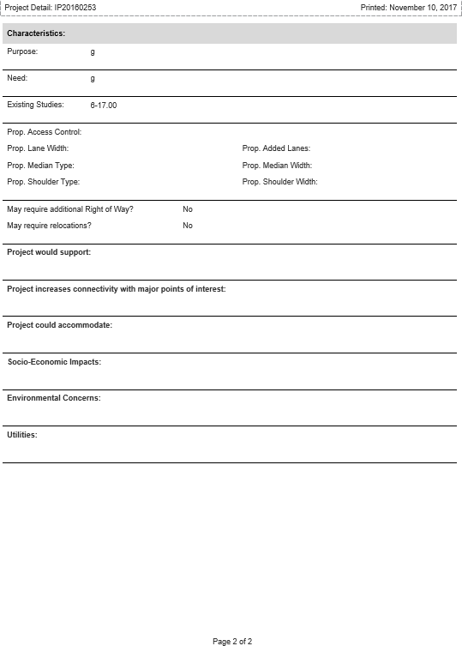

# SHIFT CYCLE

## The KYTC CHAF database is the cornerstone of the SHIFT process. Through the SHIFT process, projects that have been sponsored by the Area Development Districts (ADD), Metropolitan Planning Organizations (MPO) and KYTC are evaluated using measurable data to assess the need for and benefits of planned projects and compare them to each other. The assessment of relevant data associated to the projects is then validated and ultimately provided a project score. Any project that is looking to be assessed through the SHIFT process must be entered in CHAF first.

## Sponsorship

The sponsorship is the process in which the ADDs, MPOs and KYTC make a selection of specific projects to be evaluated through the SHIFT process. To sponsor a project, the ADD, MPO or KYTC simply click on the Sponsorship Widget (see Figure 59), which will prompt the Sponsorship web screen shown in Figure 60.

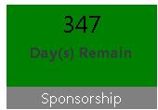**Figure 59 - Sponsorship**

The Division of Planning will notify the ADD, MPO and Highway District the specific maximum number of projects that each of them can sponsor.

## Sponsor / UnSponsor a Project

Projects can be sponsored and unsponsored by clicking on the Sponsor or UnSponsor buttons shown in Figure 60.

Note that a project only needs to be sponsored by one partner to advance to the SHIFT process and evaluation. Also, the sponsorship process has a specific timeframe, which is referenced in Figure 59The Division of Planning will notify all partners each cycle of the SHIFT schedule and timeframes. After the time period provided for the sponsorship process ends, CHAF database is locked and projects can no longer be sponsored.

Figure 60 - Sponsorship Page View

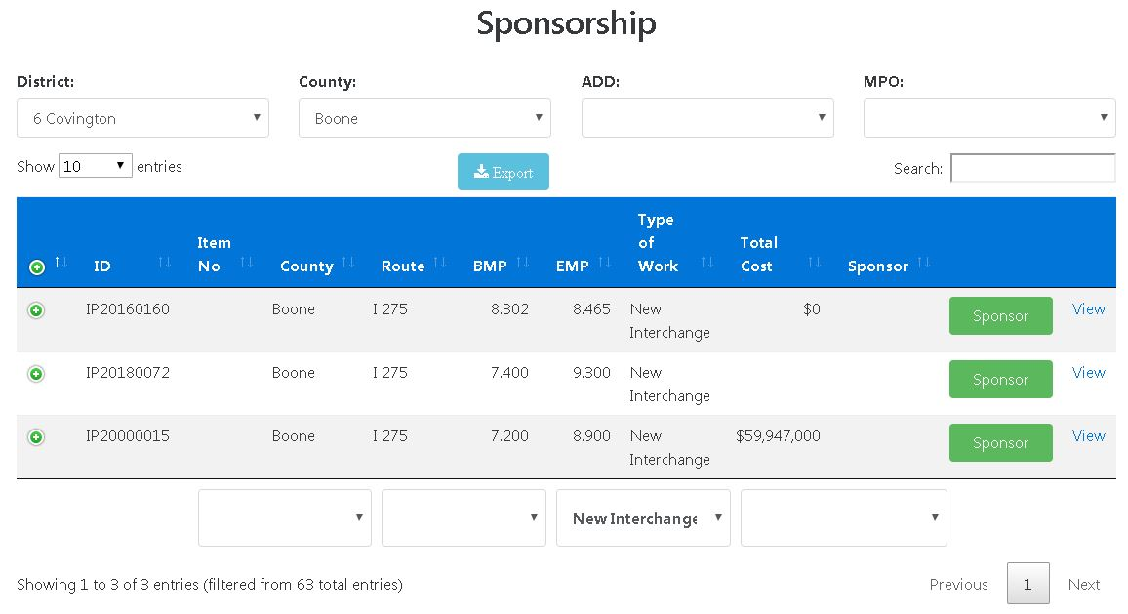

**Figure 61 – Sponsor and Unsponsored Projects**

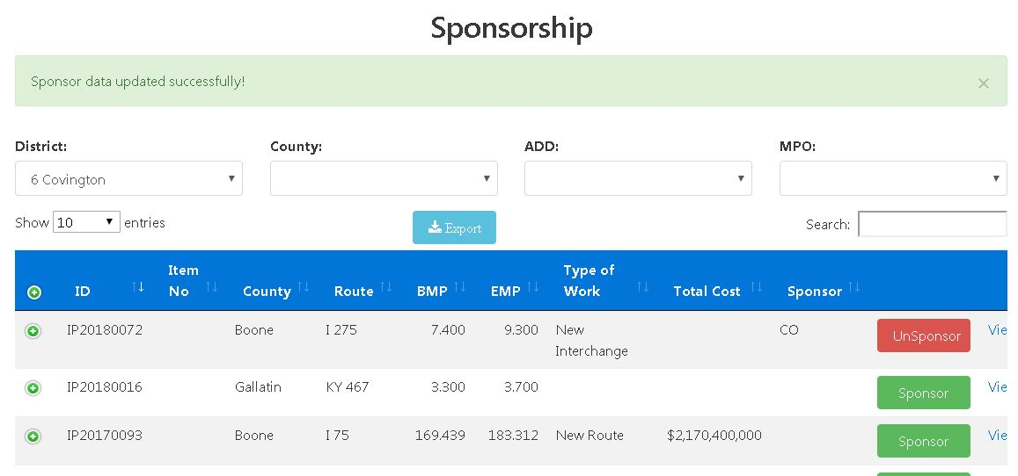

## List of Sponsored Project

The list of sponsored projects can be downloaded by pressing the Export button shown in Figure 61. This will start the download an Excel file of your sponsored projects. (See Figure 62)

**Figure 62 - List of Sponsored Projects**

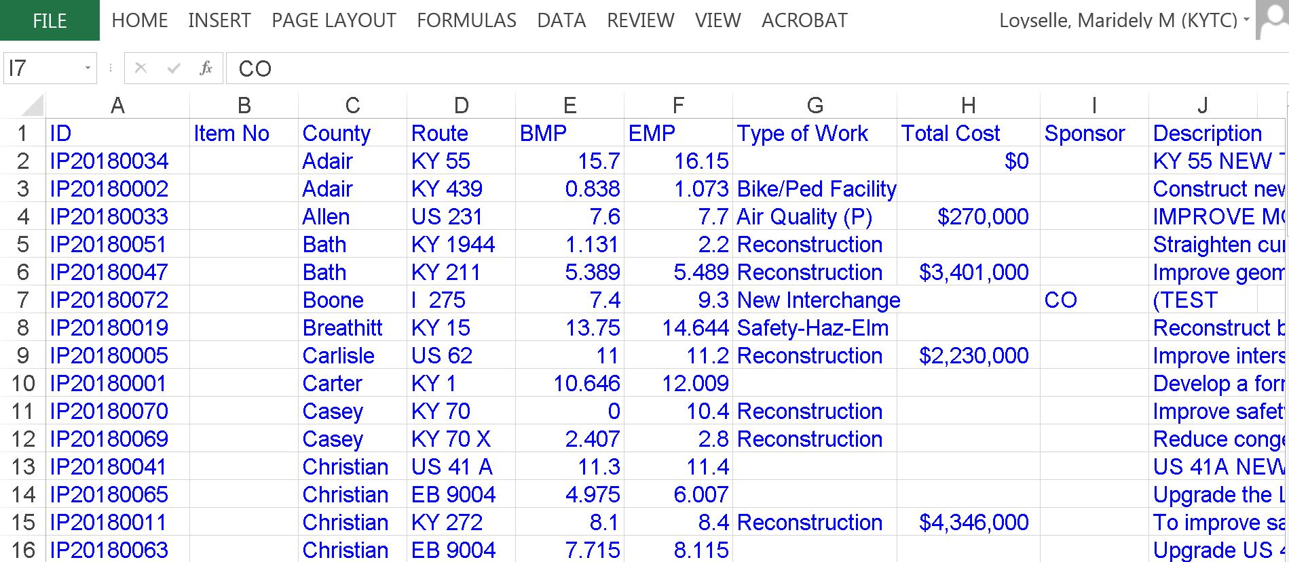

## Scoring Data Validation

The next step in the SHIFT cycle is the validation of the data and determine a project score. Figure 64 shows the Scoring Data Validation page, which include the projects and its sponsors.

The Scoring Data Validation process has a specific timeframe, as shown in Figure 64. After this time frame expires, the validation process is closed. The timeframe is set by the Division of Planning and notify to all partners at the beginning of each SHIFT Cycle.

**Figure 63 - Validation Widget**

**Figure 64 - Data Validation Page**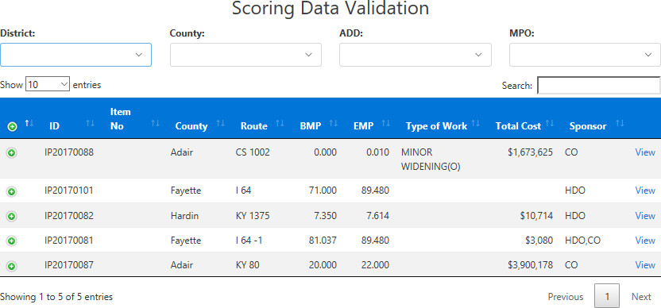

## Local Input

Once the data validation process has been completed and the preliminary score is determined, sponsors are given the opportunity to provide local input to their projects, by assessing a numerical weight based upon their local value. For every SHIFT cycle, the maximum amount of points allowed to be allocated to a project is determined by Division of Planning.

Once the time period for local input expires, as shown in Figure 65, projects are no longer available for this part of the process.

**Figure 65 - Local Input Widget**

The Local Input and the Score pages can be seen in Figures 66 and 67.

**Figure 66 - Local Input Page**

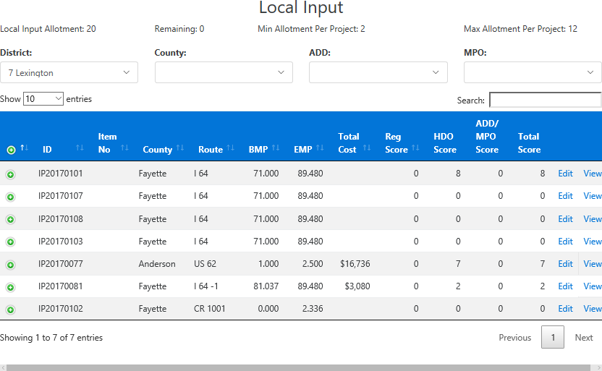

**Figure 67 - Score Page**

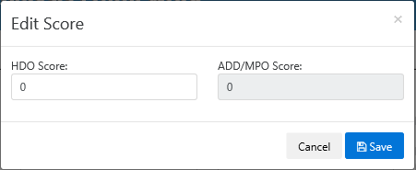

# INDEX

A

Access Request · 9

Admin · 13, 15

B

Bridge Details · 3, 26, 30, 31, 43

C

Cardinal · 3, 4, 42, 43

CHAF Users Guide · 14

D

Dashboard · 16

Data Validation · 52, 53

Description · 38

E

Edit Project · 23, 25, 26, 29, 30, 32, 34, 38, 46

Editing Projects · 25

Estimates · 3, 33

H

Home · 8, 9, 12, 13, 14, 21, 26, 38, 47

I

Identified · 27

Improvement Types (Improvement Assumptions)

2 Lane To 4 Lane Divided-Rural · 4

2 Lane To 4 Lane Divided-Urban · 4

Access Consolidation · 4

Arterial To Full Control · 4

Auxiliary Lanes Or Operational Improvements · 4

Bike And Pedestrian Improvements · 4

Cardinal Direction · 3, 4, 6, 42, 43

Construct Road In New Location · 4

Credentials · 4

Existing Route · 4

Full Control To Interstate · 5

Grade Separated To Interchange · 5

Grade Separation Of Highway/Railroad Crossing · 5

Identified Project · 5

Impacted Route · 5

Improve Intersection · 5

Improve Railroad Crossing · 5

Improvement Types (Improvement Assumptions) · 5

Innovative Intersection · 5

Install Cameras And DMS · 5

Install Two-Way Left Turn Lane · 5

Interchange Safety Improvements · 5

Local Roadway Improvements · 6

Maintenance Improvement Improvement Types (Improvement Assumptions) · 6

Major Interchange Reconstruction · 6

Major Widening-Rural Multilane · 6

Major Widening-Urban Streets · 6

Modernize Roadway-Rural · 6

Modernize Roadway-Urban · 6

Other Improvement Types · 6

Realign Intersection · 7

Road Diet · 7

Transportation Studies · 7

Upgrade To Grade Separation · 7

Improvement Types (Improvement Assumptions))

Arterial To Partial Control · 4

Improvement Types (Improvement Assumtions)

Add Lane To Full Control Facility · 4

Inactive · 27

K

KYTC Users · 3, 8, 9, 10, 12

L

Links Widgets · 18

Local Input · 18, 53, 54

Location · 3, 26, 29, 30, 38, 41

M

Map Page · 29

Mile Points · 3, 40

N

Need · 6

Non-Cardinal · 6, 42

Non-KYTC Users · 8

O

Order · 3, 6, 30, 44

P

Project Characteristics · 3, 35, 36, 37

Project Grid · 3, 18, 19

Project ID · 38

Project Improvement Assumptions · 35

Project Map · 38, 39

Project Maps · 38

Project RequesT · 21

Project Search · 3, 17, 21, 25

Project Status · 3, 27

Proposed Project Area · 6

Proposed Route · 6

Purpose · 3, 6, 32

Purpose and Need · 32

R

Report · 3, 13, 14, 47, 48, 49

Request Project · 17, 21, 22

S

Scheduled · 27

Scoring · 52

Search Existing Project · 23

SHIFT · 3, 8, 13, 16, 18, 23, 27, 42, 45, 50

Sponsor · 50, 51, 52

Sponsorship · 18, 50, 51

Status · 18, 38

T

Type Of Work · 18, 38

U

User Guide · 13, 14

User Profile · 3, 9, 11, 12, 15

User Requests · 17